**JavaScript**

JavaScript is a high-level, object-oriented, multi-paradigm programming language.

* High-Level: We don’t have to worry about complex stuff like memory management.
* Object-Oriented: Based on objects, for storing most kind of data
* Multi-paradigm: we can use different style of programming.

There is nothing we can’t do with JS.

* Front-End Apps: Dynamic effect and web application for browser. E.g.: React, Angular
* Back-End Apps: Web application on servers. E.g.: Node Js
* Native Mobile Apps: We can develop mobile application too. E.g.: React Native
* Desktop Application: We can create desktop application too. E.g.: Ion, Atomic

JavaScript Releases:

ES5->ES6/ES2015->ES7/ES2016->ES8/ES2017->ES9/ES2018->ES10/ES2019->ES11/ES2020->…

ES6- Biggest Update to the language ever, and from ES6 Modern JS ERA Started.

**JS DATA TYPES**

Value->Object or Primitive Type(Everything Else).

7 Type of Primitive type:

1. Number: Floating Point Numbers. Used for decimal and integers. E.g.: let age = 23
2. String: Sequence of Characters. Used for text. E.g.: let firstName=’Summy’
3. Boolean: Logical type that can only be true or false. Used for taking decision. E.g.: let fullAge=true;
4. Undefined: Value taken by variable that is yet to define.(empty value) E.g.: let children;
5. Null: Also means empty value
6. Symbol(ES2015): value that is unique and cannot be changed.
7. BigInt(ES2020): Larger Integers that the Number can hold.

JS has dynamic typing: We do not have to manually define the data type of the value stored in variable. Instead data type are determined automatically.

**Boolean Logic**:

1. AND- A AND B – true when all are true.
2. OR- A OR B – true when one is true.
3. NOT - !A- inverts true/false value.

Backward Compatibility: Don’t Break Web.

JS is designed in that way, even if we use modern JS it is backward compatible with old JS(1997) because then it won’t break any functionality and it would work fine. It is Backward Compatible.

* Old features are never removed
* Not really new version, just incremental version
* Websites keep working forever

let js = "amazing";

console.log(js)// amazing

console.log(40 + 8 + 23 - 10);

// **Values and Variables**

console.log("Jonas");

console.log(23);

let firstName = "Matilda";

console.log(firstName); //matilda

console.log(firstName); //matilda

let firstName="summy";

let lastName = "singh";

console.log("First name is: "+firstName);

console.log("Last Name is: "+lastName);

console.log("Full Name is: "+firstName +" "+lastName);

let jsBool = true;

console.log(jsBool); //true

console.log(typeof(jsBool)); //boolean

console.log(typeof jsBool); //boolean

console.log(typeof true); //boolean

console.log(typeof 3); //number

console.log(typeof(3)); //number

console.log(typeof NaN); //number

console.log(typeof(NaN)); //number

console.log(typeof null); //object

console.log(typeof(null)); //object

console.log(typeof string); //undefined

console.log(typeof 'summy'); //string

let jsIs;

console.log(typeof ''); //string

console.log(typeof jsIs); //undefined

console.log(typeof 3.14); //number

let javascriptIsFun = 'YES!';

console.log(typeof javascriptIsFun);//string

// **Basic Operators**

// **Math operators**

const year=2020

const ageSummy = year-1996;

const ageSunny=year-1993;

console.log(ageSummy, ageSunny);

console.log(ageSummy*2, ageSummy+10, ageSummy/2, ageSummy%2);

console.log(ageSummy*2);

console.log(ageSummy+10);

console.log(ageSummy/2);

console.log(ageSummy%5);

console.log(2**3);//mean 2 to the power 3

//**assignmnet operator**

// let x=10+15;

// console.log(x);

// x+=10;

// console.log(x);

// x-=10;

// console.log(x);

// x*=10;

// console.log(x);

// x++;

// console.log(x);

// x--;

// console.log(x);

// ++x;

// console.log(x);

// --x;

// console.log(x)

//**conparison operator** >,<,>=,<= it will return true or false

// const now = 2020;

// const ageSummy = now-1996;

// const ageSunny = now-1994;

// console.log(now-1994>now-1996) //true

// **Operator Precedence**

const now = 2037;

const ageJonas = now - 1991;

const ageSarah = now - 2018;

console.log(now - 1991 > now - 2018); //true

const averageAge = (ageJonas + ageSarah) / 2;

console.log(ageJonas, ageSarah, averageAge); //46 19 32.5

let x, y;

x = y = 25 - 10 - 5; // x = y = 10, x = 10

console.log(x, y);

//**string**

const fName = 'summy';

const job = 'developer';

const birthYear = 1996;

const year = 2020;

const summy = "I'm "+fName+', a '+(year-birthYear)+' Year old '+job+' !';

console.log(summy);

//**template literal**

const summyNew = `I'm ${fName}, a ${year-birthYear} years old ${job}!`

console.log(summyNew);

console.log(`just a regular string`);

console.log('string \n\ with \n\ multiple lines');

console.log(`string

with multiple line

using literals`);

// **Taking Decisions**: if / else Statements

if (age >= 18) {

console.log('Sarah can start driving license 🚗');

} else {

const yearsLeft = 18 - age;

console.log(`Sarah is too young. Wait another ${yearsLeft} years :)`);

}

const birthYear = 2012;

let century;

if (birthYear <= 2000) {

century = 20;

} else {

century = 21;

}

console.log(century);

// **Type Conversion and Coercion**

**Type Conversion**: Type conversion is when we manually convert one type to another.

**Type Coersion:** Type coercion is when JS automatically convert one type to another behind the scene for us.

// **type conversion**

const inputYear = '1991';

console.log(Number(inputYear), inputYear); //1991(n),1991(s)

console.log(Number(inputYear) + 18); //2009

console.log(+inputYear); //1991(number)

console.log(Number('Jonas')); //NaN

console.log(typeof NaN); //number

console.log(String(23), 23); //23(n), 23(s)

//**type coercion**

console.log('I am '+23+' Years old');

//whenever js sees a + operator it automatically convert number to string

console.log('23'-'10'-3); //3 //string to number

console.log('23'-'10'); //13

console.log('23'+'10'+3); //23103 //number to string

console.log('13'*'2'); //26

//**5 falsy value**---0,'',undefined,null,Nan

console.log(Boolean(0)); //false

console.log(Boolean('')); //false

console.log(Boolean(undefined)); //false

console.log(Boolean(null)); //false

console.log(Boolean(NaN)); //false

console.log(Boolean({}));//empty object it is //true

console.log(Boolean(2)); //true

//**if else scenerio for falsy value**

const money=0;

if(money){

console.log("Don't spend all")

}else{

console.log("Get a Job!");

}//return false because of 0

let height; //height is undefined here and it is falsy

if(height){

console.log("It's true that you have height");

}else{

console.log("Stop using Undefined, please define your height");

}

// **Equality Operators: == vs. ===**

**= = = : Strict equality operator**, it’s strict because it does not perform type coercion. It returns true when both values are exactly the same.

**= =** : **Loose Equality Operator,** actually does type coercion.

e.g. ‘18’==18 -> true.

const age = '18';

if (age === 18) console.log('You just became an adult :D (strict)');

if (age == 18) console.log('You just became an adult :D (loose)');

const favourite = Number(prompt("What's your favourite number?"));

console.log(favourite);

console.log(typeof favourite);

if (favourite === 23) { // 22 === 23 -> FALSE

console.log('Cool! 23 is an amzaing number!')

} else if (favourite === 7) {

console.log('7 is also a cool number')

} else if (favourite === 9) {

console.log('9 is also a cool number')

} else {

console.log('Number is not 23 or 7 or 9')

}

if (favourite !== 23) console.log('Why not 23?');

//**PROMPT-** takes input from the browser and it return string by default.

const fav = prompt("what is your fav number?");

console.log(fav);

//**logical Operator**

const hasDriversLicense = true; //A

const hasGoodVision = false; //B

console.log(hasDriversLicense && hasGoodVision); //false

console.log(hasDriversLicense || hasGoodVision); //true

console.log(!hasGoodVision); //true

//**switch case**

const day = 'saturday';

switch(day){

case 'monday':

console.log("It's Monday");

break;

case 'tuesday':

console.log("It's Tuesday");

break;

case 'wednesday':

console.log("It's Wednesday");

break;

case 'thursday':

console.log("It's Thursday");

break;

case 'friday':

console.log("It's Friday");

break;

case 'saturday':

case 'sunday':

console.log("It's Weekend");

break;

default:

console.log('Take a break!');

}

//**ternary operator**

const age = 23;

age>=18?console.log("adult man"):console.log("you are a minor");

const drink = age>=18?'wine':'water';

console.log(drink);

console.log(`I would like to drink ${age>=18?'wine':'water'}`);

// **Statements and Expressions**

* An **Expression** is a piece of code that produces a value e.g. 3+4(Produces a value).
* An **Statements** is like a bigger piece of code that is executed and which does not produce a value on itself.(Are like full sentences, that translate our actions).

**Declarations are like statements, and expressions are like the words.**

3 + 4

1991

true && false && !false

if (23 > 10) {

const str = '23 is bigger';

}

const me = 'Jonas';

console.log(`I'm ${2037 - 1991} years old ${me}`);

**Let, Var and Const**

1. **Let**: let age: number or let age=30 -> age=31

* We can reassign a value to a variable, also we can say that we can mutate the age variable in this case.
* When we need that kind of variable, then this is the perfect use case for let.
* For empty variable also.

1. **Const**: To declare a variable that are not supposed to change the value. i.e. value can’t be changed.

* By default, always just use const, and let when you are sure that the value of the variable need to change at some point of the code.

1. **Var**: var job = ‘Programmer’;-> job=’Developer’[Before ES6]

* Let is block-scoped and Var is function-scoped.

**Strict Mode :** It is a special mode which we can activate in JS, which makes it easier for us to write secure code.

‘use strict’ at the top of the JS file.

-to avoid accidental errors

-forbid us to do certain things

-create visible errors

**Function:** A piece of code, that we can use again and again according to the requirement.

* A variable can hold a value, but a function can hold one or more complete lines of code.
* We pass data to function and additionally, a function can return data as well
* Parameter are like variable that are specific only to the function and they will get defined once we call the function.
* We can think of these parameter of empty spaces that still need to be fill out when we are writing the function.
* And, when we call the function, we then fill these empty spaces by passing the real specific value. Which will then get assigned to the parameters.
* **If a function does not produce/return value, technically it does produce undefined. We don’t capture undefined value**
* Parameter is like a local variable, that is only available inside the function.
* Parameter is the kind of placeholder in the function.
* Arguments is the actual value that we use to fill in the placeholder.

// Functions

function logger() {

console.log('My name is Jonas');

}

// calling / running / invoking function

logger();

logger();

logger();

function fruitProcessor(apples, oranges) {

const juice = `Juice with ${apples} apples and ${oranges} oranges.`;

return juice;

}

const appleJuice = fruitProcessor(5, 0);

console.log(appleJuice);

const appleOrangeJuice = fruitProcessor(2, 4);

console.log(appleOrangeJuice);

**Function Expression:** Also called an anonymous function.

// Function Declarations vs. Expressions

// **Function declaration**

function calcAge1(birthYeah) {

return 2037 - birthYeah;

}

const age1 = calcAge1(1991);

// **Function expression**

const calcAge2 = function (birthYeah) {

return 2037 - birthYeah;

}

const age2 = calcAge2(1991);

console.log(age1, age2);

* And expression produces values, so we just assigned this whole expression to this variable, will then hold this function value basically.
* In JS, functions are just values.
* Function is not a type like number, string type. It is a value and we can store it in a variable.

Main difference between function declaration and expression is we can actually call function declaration before they are defined in the code. i.e. Function Hoisting.

**Arrow Function(ES6)**: Arrow function is simply a special form of function expression that is shorter and therefore faster to write.

* We loose advantage of arrow function with complex code.
* Arrow function do not get so-called **this Keyword.**

// **Arrow functions**

const calcAge3 = birthYeah => 2037 - birthYeah;

const age3 = calcAge3(1991);

console.log(age3);

const yearsUntilRetirement = (birthYeah, firstName) => {

const age = 2037 - birthYeah;

const retirement = 65 - age;

// return retirement;

return `${firstName} retires in ${retirement} years`;

}

console.log(yearsUntilRetirement(1991, 'Jonas')); console.log(yearsUntilRetirement(1980, 'Bob'));

// **Functions Calling Other Functions**

function cutFruitPieces(fruit) {

return fruit * 4;

}

function fruitProcessor(apples, oranges) {

const applePieces = cutFruitPieces(apples);

const orangePieces = cutFruitPieces(oranges);

const juice = `Juice with ${applePieces} piece of apple and ${orangePieces} pieces of orange.`;

return juice;

}

console.log(fruitProcessor(2, 3));

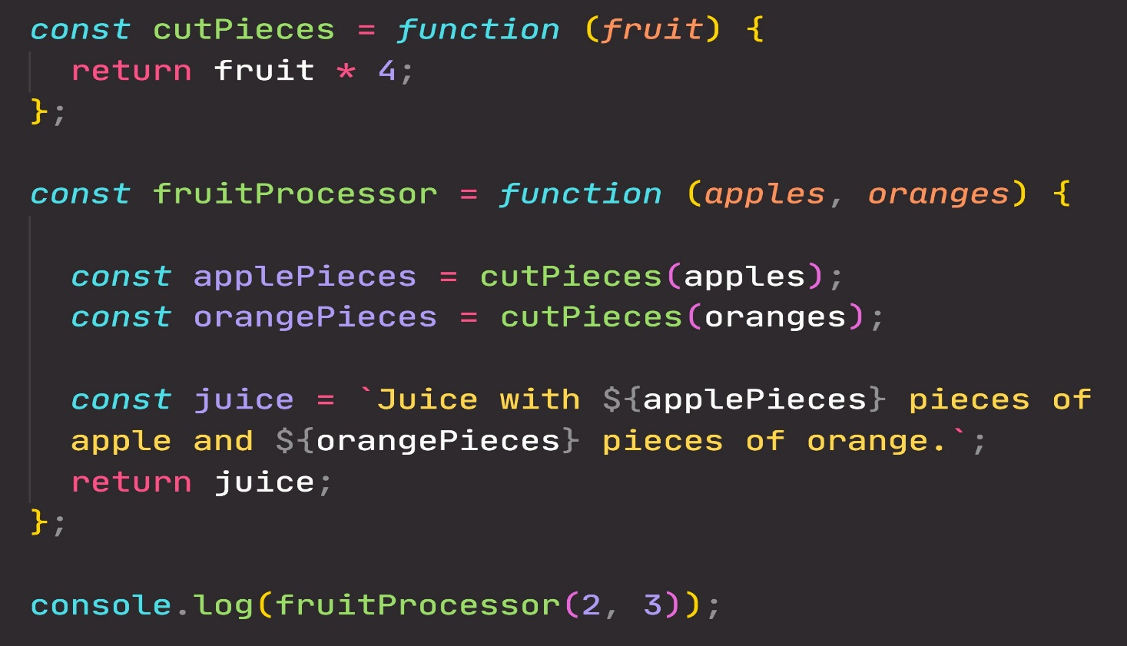

**2**

**2**

**8**

**2**

**8**

**8**

**3**

**2**

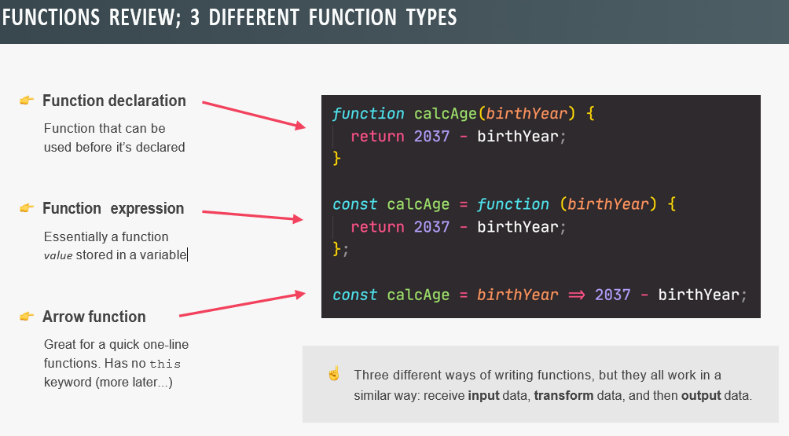

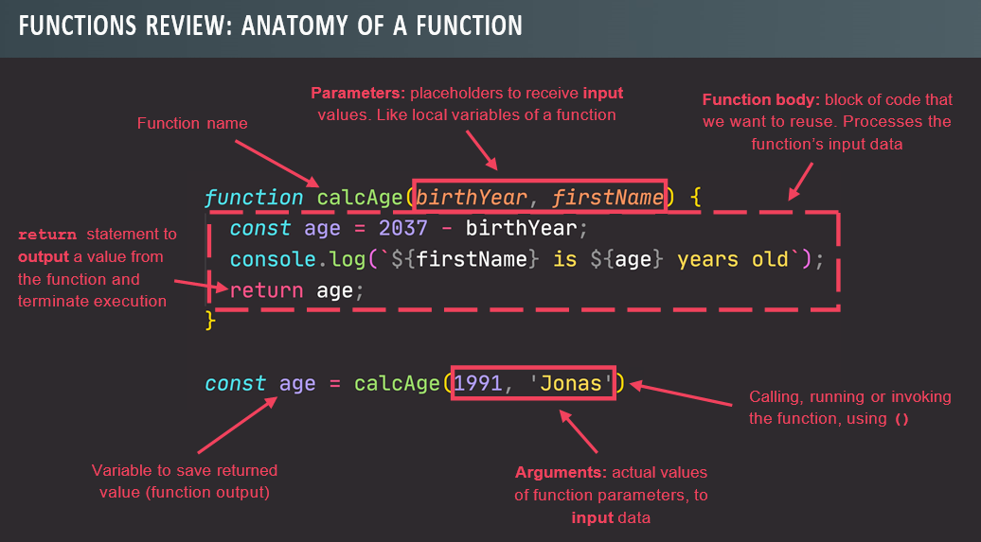

**Array**: We can change array even if it is declared as const.

* Because only primitive values are immutable. But array is not a primitive value and change it and that is why it is immutable.
* We cannot replace the entire array.

//Arrays

// const friends = ['summy','ranjeet','shubham','vishal','vicky']; //**literal syntax to create array**

// console.log(friends);

// const years = new Array(2018,2019,2020,2021,2022,2023); //**array function to create array**

// console.log(years);

// **Introduction to Arrays**

const friend1 = 'Michael';

const friend2 = 'Steven';

const friend3 = 'Peter';

const friends = ['Michael', 'Steven', 'Peter'];

console.log(friends);

const y = new Array(1991, 1984, 2008, 2020);

console.log(friends[0]);

console.log(friends[2]);

console.log(friends.length); //3

console.log(friends[friends.length - 1]); //peter

friends[2] = 'Jay';

console.log(friends); //micheal,steven,jay

// friends = ['Bob', 'Alice']

const firstName = 'Jonas';

const jonas = [firstName, 'Schmedtmann', 2037 - 1991, 'teacher', friends];

console.log(jonas);

console.log(jonas.length);

**Array Methods**:

// Basic Array Operations (Methods)

const friends = ['Michael', 'Steven', 'Peter'];

// **Add elements**

const newLength = friends.push('Jay'); //Add to the end

console.log(friends);

console.log(newLength);

friends.unshift('John'); //Add to the start

console.log(friends);

// **Remove elements**

friends.pop(); // Remove from Last

const popped = friends.pop();

console.log(popped);

console.log(friends);

friends.shift(); // Remove from First

console.log(friends);

console.log(friends.indexOf('Steven')); //Gives the index of element

console.log(friends.indexOf('Bob'));

friends.push(23); // check if element exist in the array

console.log(friends.includes('Steven'));

console.log(friends.includes('Bob'));

console.log(friends.includes(23));

**Includes(ES6)**: Instead of returning the index of the element we simply return true if the element is in the array, and false if not.

* It check strict equality and it does not do type coercion.

**Objects**: Key-Value Pair

-Key is also called properties

-Order does not matter in object, to retrieve them unlike array

-Properties are ordered alphabetically

-Can retrieve data using two way:

1.Dot Notation

2.Bracket Notation- We can put expression and compute it in this.

// **Introduction to Objects**

const jonasArray = [

'Jonas',

'Schmedtmann',

2037 - 1991,

'teacher',

['Michael', 'Peter', 'Steven']

];

//cannot provide fname, lname,job and all details in array and that is why object come and help

Console.log(jonasArray);

//**object literal syntax and easiest way to write**

const jonas = {

firstName: 'Jonas',

lastName: 'Schmedtmann',

age: 2037 - 1991,

job: 'teacher',

friends: ['Michael', 'Peter', 'Steven']

};

Key is also called Properties, so we can say this object jonas have 5 properties.

// **Dot vs. Bracket Notation**

/dot notation

console.log(jonas.age);

console.log(jonas.fName);

//bracket notation

console.log(jonas ['lName']);

jonas.zodiac = 'Taurus';

jonas ['passion']='photography';

console.log(jonas);

// **Object Methods**

const jonas = {

firstName: 'Jonas',

lastName: 'Schmedtmann',

birthYeah: 1991,

job: 'teacher',

friends: ['Michael', 'Peter', 'Steven'],

hasDriversLicense: true,

// calcAge: function (birthYeah) {

// return 2037 - birthYeah;

// }

// calcAge: function () {

// // console.log(this);

// return 2037 - this.birthYeah;

// }

calcAge: function () {

this.age = 2037 - this.birthYeah;

return this.age;

},

getSummary: function () {

return `${this.firstName} is a ${this.calcAge()}-year old ${jonas.job}, and he has ${this.hasDriversLicense ? 'a' : 'no'} driver's license.`

}

};

console.log(jonas.calcAge()); //46

console.log(jonas["calcAge"]()) //46

console.log(jonas.age); //46

**Loops**: Loop are a fundamental aspect of every programming language because they allow us to automate repetitive task.

-**Continue**: Continue is to exit the current iteration of the loop and continue to the next one.

-**Break**: Break is used to completely terminate the whole loop.

//**For Loop**

1.for(let rep=1;rep<=15;rep++){

console.log('Rep No: '+rep);

}

2.for(let rep=1;rep<=15;rep++){

console.log(`Rep No: ${rep}`);

}

3. const summyArray = [

'summy',

'singh',

1996,

'software developer',

2020-1996

];

const types=[];

for(let i=0;i<summyArray.length;i++){

//reading data from summyArray

console.log(summyArray[i]);

//Reading data and type

//console.log(summyArray[i], typeof summyArray[i]);

//filling type array

//types[i]=typeof summyArray[i];

types.push(typeof summyArray[i]);

}

//console.log(types);

//**continue and break**

//**Continue**

// console.log("-----Only Strings------")

// for(let i=0;i<summyArray.length;i++){

// if(typeof summyArray[i] !== 'string'){

// continue;

// //console.log(summyArray[i], typeof summyArray[i])

// }

// console.log(summyArray[i], typeof summyArray[i])

// }

//**Break**

// console.log("-----Break with Number------")

// for(let i=0;i<summyArray.length;i++){

// if(typeof summyArray[i] === 'number'){

// break;

// //console.log(summyArray[i], typeof summyArray[i])

// }

// console.log(summyArray[i], typeof summyArray[i])

// }

//**looping backward**

// const summyArray = [

// 'summy',

// 'singh',

// 1996,

// 'software developer',

// 2020-1996

// ];

// for(let i = summyArray.length-1;i>=0;i--){

// console.log(i,summyArray[i]);

// }

//**While loop**

// let rep=0;

// while(rep<=10){

// console.log(`Rep No: ${rep}`);

// rep++;

// }

**DOM: Document Object Model:** Structured representation of HTML Documents. Allows JS to access html elements and styles to manipulate them.

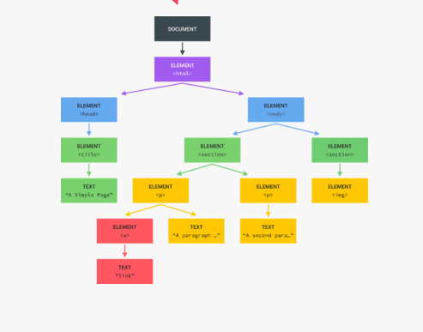

Tree structure, generated by browser on HTML Load.

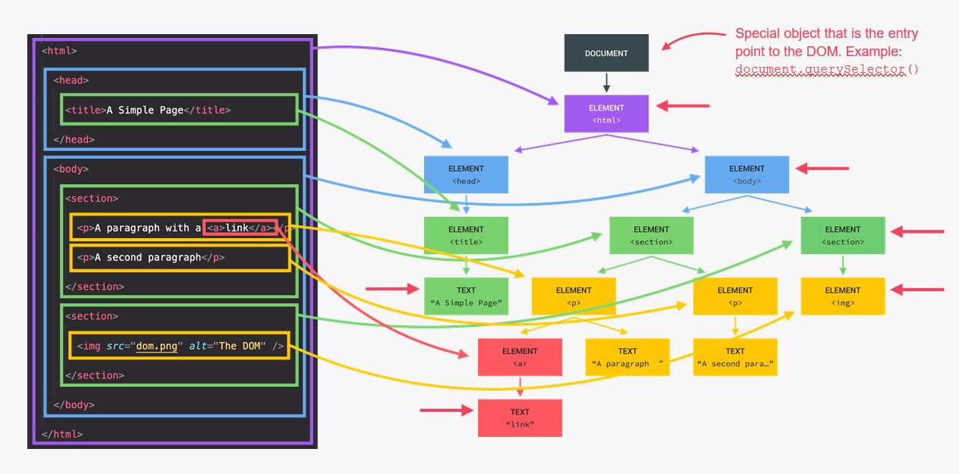

-Makes JS Interact with Web Page is DOM Manipulation.

**What is DOM?**

Structured representation of html document. Allows JS to access html element and style to manipulate them.

-The DOM is automatically created by the browser as soon as the HTML Page loads and it stored in a tree structure.

-DOM is basically a connection point between HTML document and JS Code.

-Everything in DOM structure, every element has a node in tree, and we can access and interact with each of these nodes using JS.

-DOM stands with document object, and document is a special object we have access in JS. And this special object serves as a entry point in the DOM.

-DOM is not part of JS language, actually DOM & it’s method(querySelector)are actually part of something called the WebAPIs.

-So the WebAPIs are like libraries that browser implement and that we can access from our JS Code.

console.log(document.querySelector('.message').textContent);

document.querySelector('.message').textContent = '🎉 Correct Number!';

document.querySelector('.number').textContent = 13;

document.querySelector('.score').textContent = 10;

document.querySelector('.guess').value = 23;

console.log(document.querySelector('.guess').value);

document.querySelector('.check').addEventListener('click', function () {

const guess = Number(document.querySelector('.guess').value);

console.log(guess, typeof guess);

const displayMessage = function (message) {

document.querySelector('.message').textContent = message;

};

document.querySelector('body').style.backgroundColor = '#60b347';

document.querySelector('.number').style.width = '30rem';

**Modal**

const modal = document.querySelector('.modal');

const overlay = document.querySelector('.overlay');

const btnCloseModal = document.querySelector('.close-modal');

const btnsOpenModal = document.querySelectorAll('.show-modal');

const openModal = function () {

modal.classList.remove('hidden');

overlay.classList.remove('hidden');

};

const closeModal = function () {

modal.classList.add('hidden');

overlay.classList.add('hidden');

};

for (let i = 0; i < btnsOpenModal.length; i++)

btnsOpenModal[i].addEventListener('click', openModal);

btnCloseModal.addEventListener('click', closeModal);

overlay.addEventListener('click', closeModal);

document.addEventListener('keydown', function (e) {

// console.log(e.key);

if (e.key === 'Escape' && !modal.classList.contains('hidden')) {

closeModal();

}

});

document.getElementById(`current--${activePlayer}`).textContent = 0;

const switchPlayer = function () {

document.getElementById(`current--${activePlayer}`).textContent = 0;

currentScore = 0;

activePlayer = activePlayer === 0 ? 1 : 0;

player0El.classList.toggle('player--active');

player1El.classList.toggle('player--active');

};

**High-Level Overview of JavaScript**

-It is a high level, object-oriented, Multi-Paradigm Programming Language.

-JavaScript is a high-level, Prototype-Based Object-Oriented, Multi-Paradigm, Interpreted or Just-In-Time Complied, Dynamic, Single Threaded, Garbage-Collected Programming language with first-class function and a non-blocking event loop concurrency model.

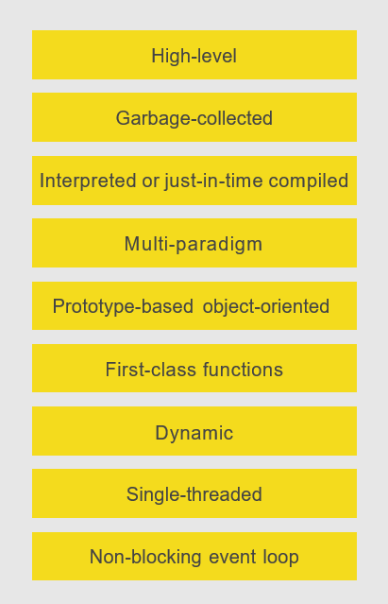

1. **High-Level**: Developer does not have to worry, everything happens automatically.
2. **Garbage Collected**: Cleaning the memory, so we don’t have to.
3. **Interpreted or JIT:** Convert the code into machine by compiling.
4. **Paradigm:** An approach and mindset of structuring code, which will direct your coding style and technique.

**-**3 Popular Paradigm are:

* Procedural Programming
* Object Oriented Programming
* Functional Programming

-**Imperative and Declarative**

1. **Prototype-Based Object-Oriented:**

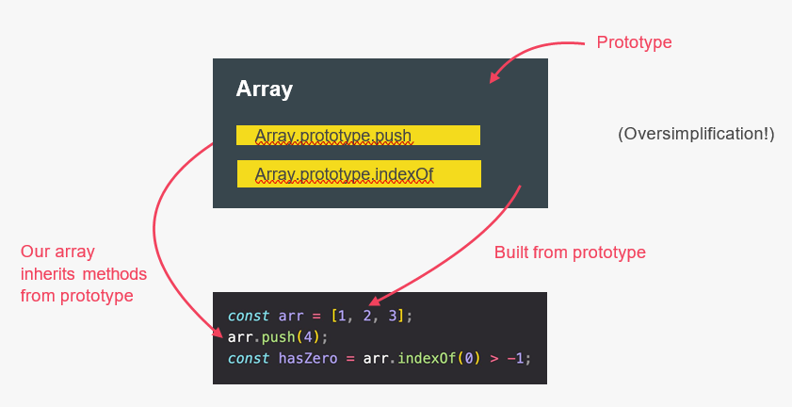

1. **First-Class Function**: Function are simply treated as variable. We can pass them into other function and return them from function.

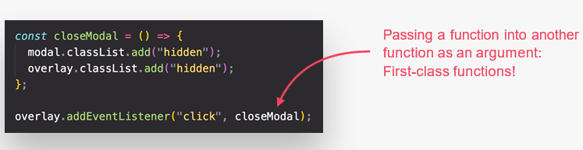

1. **Dynamic-Typed Function**:

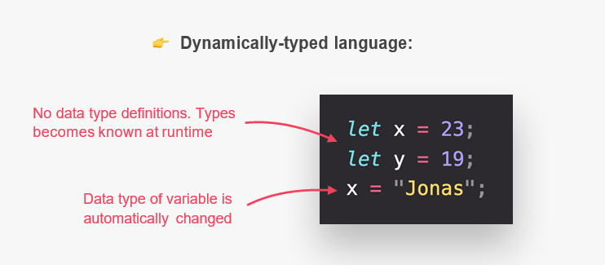

1. **Concurrency Model**:

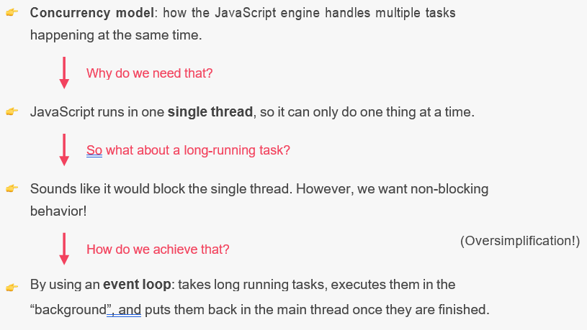

**JavaScript Engine & Runtime**:

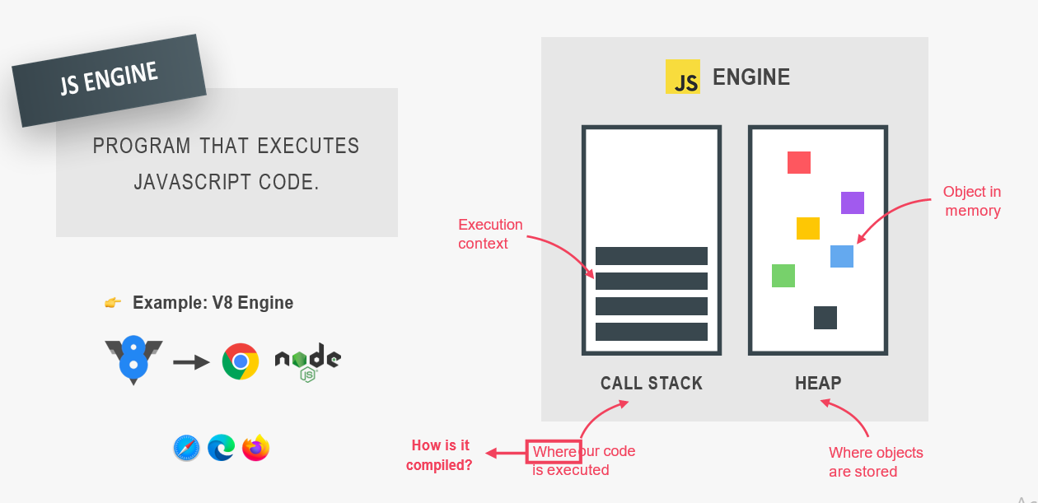

Every Single computer program ultimately needs to be converted into this machine code, and this can happen using compilation or interpretation.

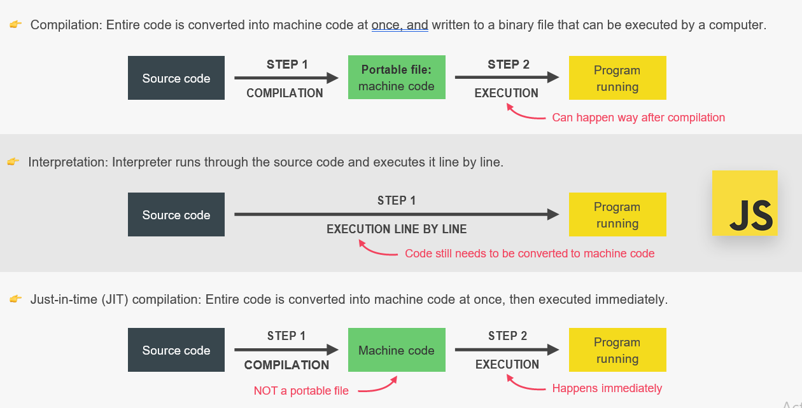

AST: Abstract Syntax Tree

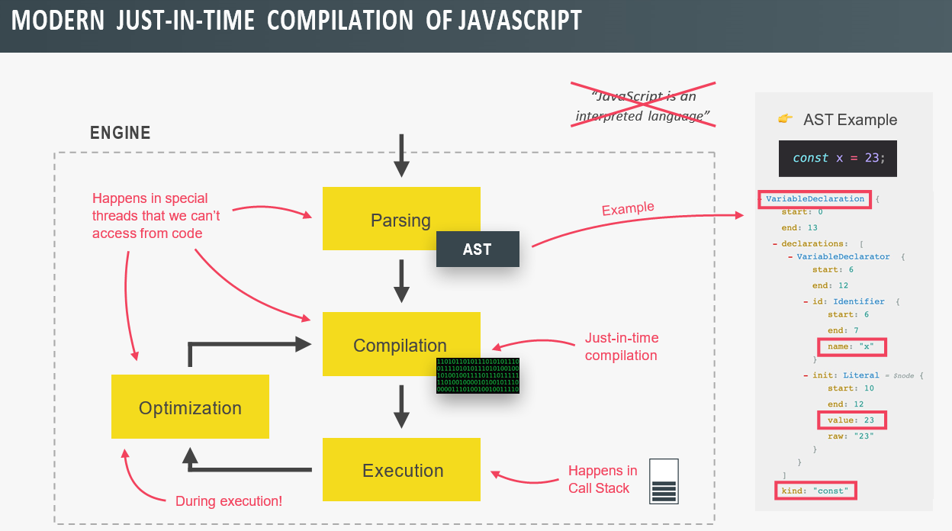

**Execution Context and the Call Stack**

**Execution Context:** Environment in which a piece of JS is executed. Stores all the necessary information for some code to be executed.

-Exactly one global execution context(EC): Default context, created for code that is not inside any function.

-One execution context per function: For each function call, a new execution context is created.

-All together make the call stack.

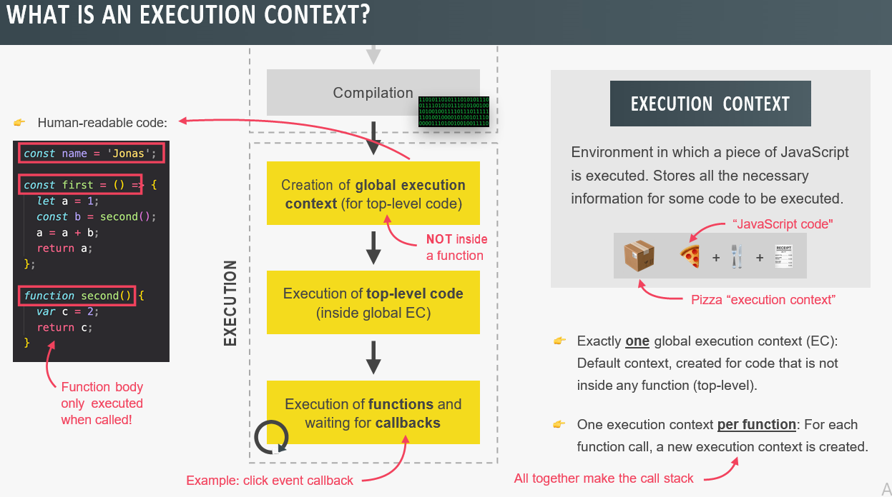

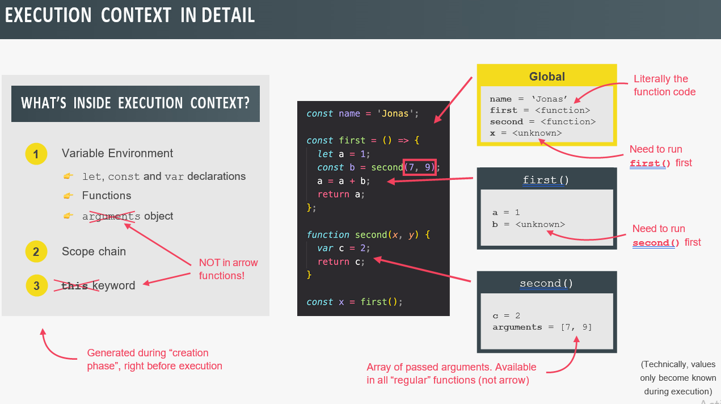

**What’s inside Execution Context?**

1. Variable Environment
2. Scope Chain
3. This Keyword

All are generated during ‘execution phase’ right before execution.

->**Arrow function do not have argument object or this keyword**

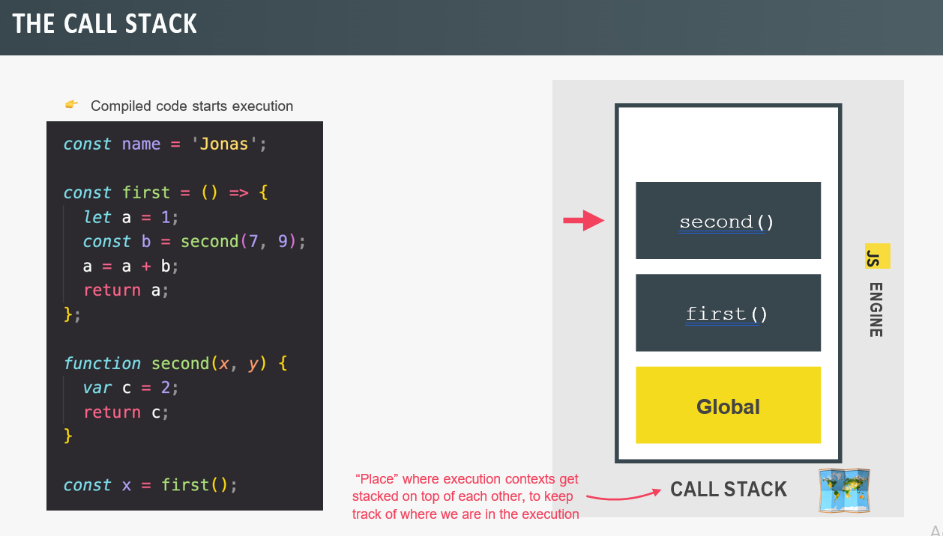

**Scoping and Scope in JS**

* **Scoping:** How our program’s variable are accessed and organized. “Where do variable lives”?
* **Lexical Scoping:** Scoping is controlled by placement of function and blocks in the code.
* **Scope:** Space or environment in which certain variable is declared. There is Global Scope, Functional Scope and Block Scope.
* **Scope of Variable:** Region of our code where a certain variable can be accessed.

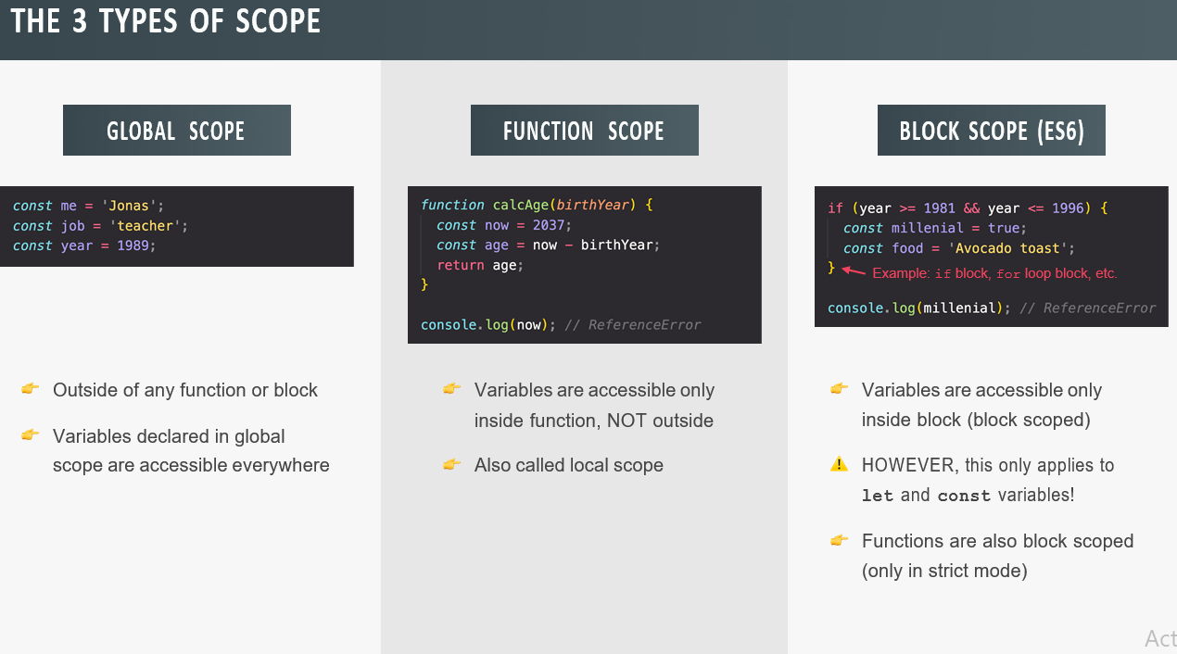

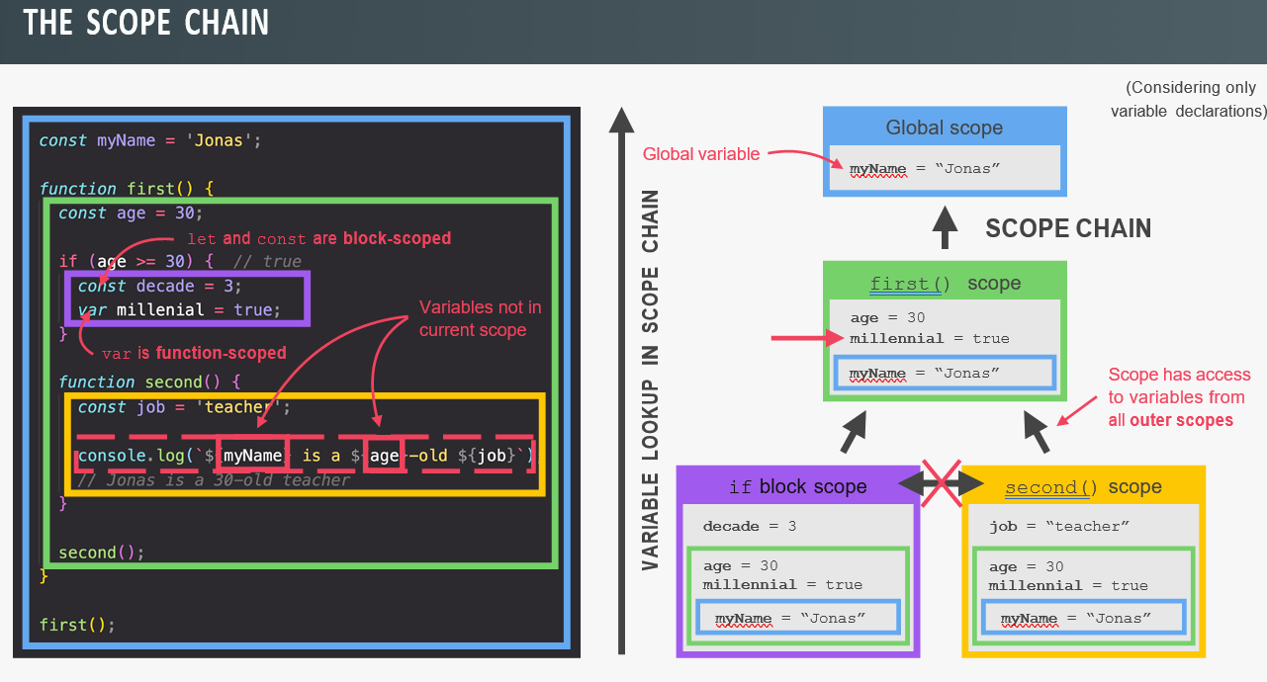

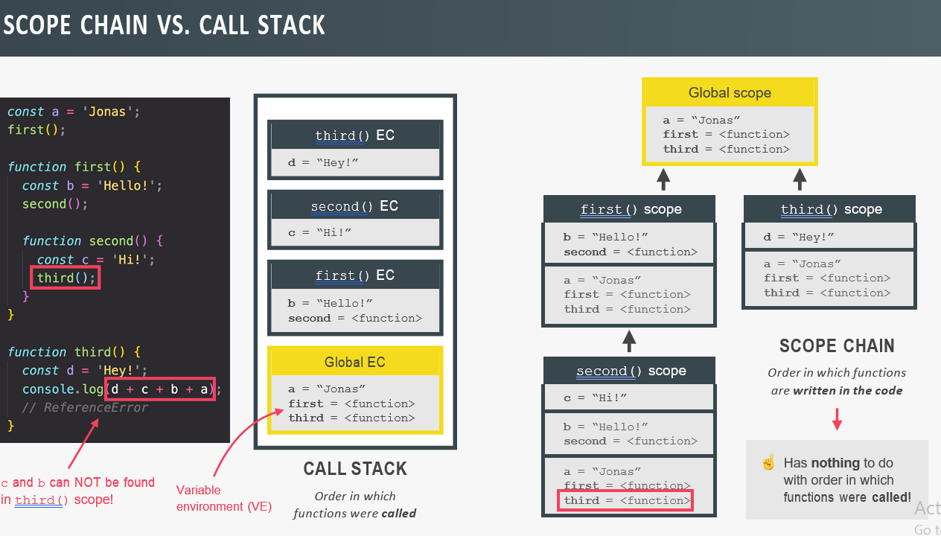

**Summary:**

* Only **let** and **const** variable are block-scoped. Variable declared with **Var** are end up or available for the closest function call.
* In JS, we have lexical scoping, so the rule of where we can access variables are based on exactly where in the code function and blocks are written.
* Every scope has access to all the variable from all its outer scope. This is the scope chain.
* When a variable is not in the current scope, the engine looks up in the scope until it finds the variable it is looking for. This is called **Variable Lookup**.
* The scope chain is a one way street: A scope will never, ever have access to the variable of an inner scope.
* The scope chain in a certain scope is equal to adding together all the variable environment of all the parent scope.
* The scope chain has nothing to do with the order in which function were called. It does not affect the scope chain at all.
* Variable declared with **var** keyword are function scoped.

**Hoisting:** Makes some types of variable accessible/usable in the code before they are actually declared. “Variable lifted to top of their scope”.

-(BTS)Before execution, code is scanned for variable declaration, and for each variable, a new property is created in the variable environment object.

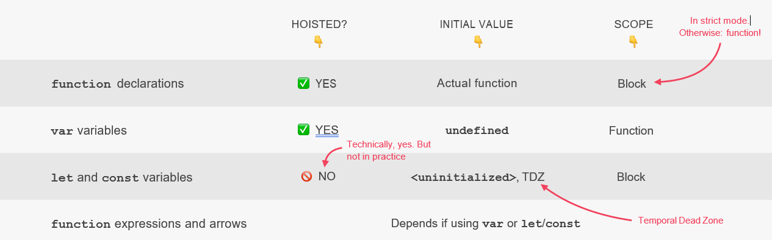

**Temporal Dead Zone(TDZ)**: Temporal Dead Zone, which makes it so that we can’t access the variable between the beginning of the scope and the place where **var** is declared.

**Why TDZ?**

-Makes it easier to avoid and catch error: Accessing variable before declaration is bad practice and should be avoided.

-Makes const variable actually work.

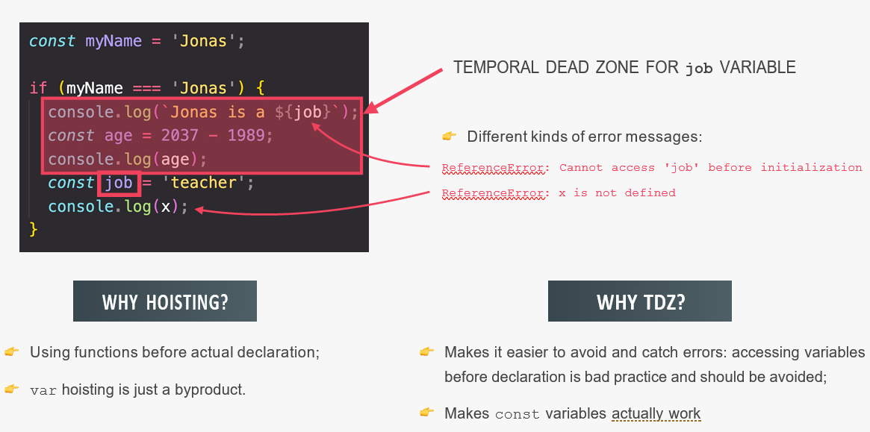

**Difference between let, var and const**

The variable declared with **var** keyword creates windows properties while declared with **let & const** will not create window properties.

**This Keyword**: Special variable that is created for every execution context(every function).

-Takes the value of(point to) the “owner” of the function in which this keyword is used.

-this is not static. It depends on how the function is called, and it’s value is only assigned when the function is actually called.

-Arrow function do not get their own ‘this’ keyword, it will point to the parent function/surrounding function.

-this does not point to the function itself, and also NOT the its variable environment.

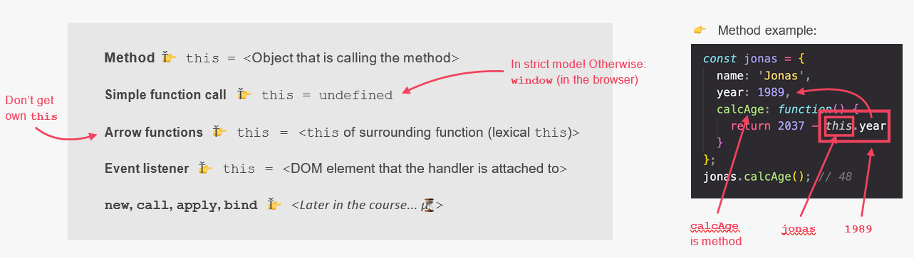

**Primitives vs Object(Primitive vs Reference types)**

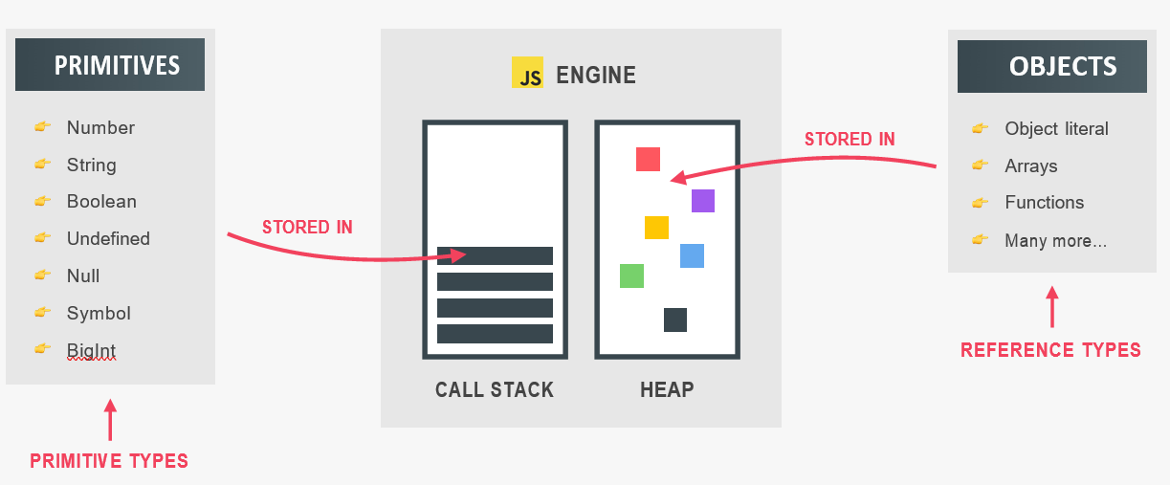

-Object might be too large to stored in stack, instead they store in heap, and give their memory address in stack to variable to point that.

-Stack just keeps the reference to where object stored in heap.

-We can change value of const, only when working with non-primitive type i.e. with object and not with primitive type.

-For Primitive re-assign of value is important to change the value.

-For Reference type we don’t need to reassign value because it changes everything on memory address which point to the heap.

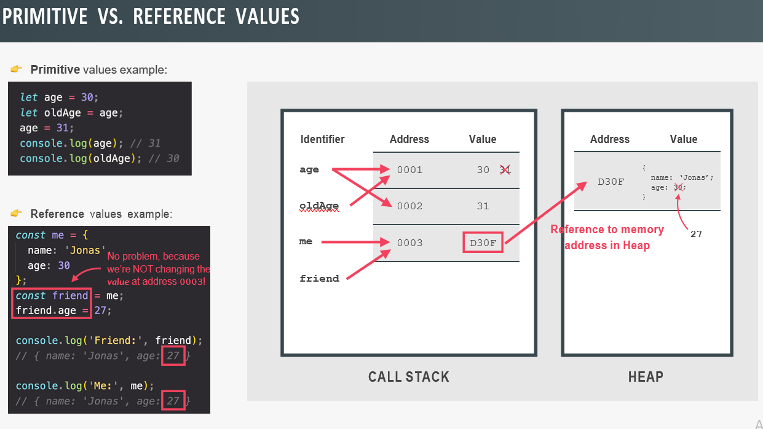

// **Hoisting and TDZ in Practice**

// Variables

console.log(me);

// console.log(job);

// console.log(year);

var me = 'Jonas';

let job = 'teacher';

const year = 1991;

// Functions

console.log(addDecl(2, 3));

// console.log(addExpr(2, 3));

console.log(addArrow);

// console.log(addArrow(2, 3));

function addDecl(a, b) {

return a + b;

}

const addExpr = function (a, b) {

return a + b;

};

var addArrow = (a, b) => a + b;

// Example

console.log(undefined);

if (!numProducts) deleteShoppingCart();

var numProducts = 10;

function deleteShoppingCart() {

console.log('All products deleted!');

}

var x = 1;

let y = 2;

const z = 3;

console.log(x === window.x);

console.log(y === window.y);

console.log(z === window.z);

// **The this Keyword in Practice**

console.log(this);

const calcAge = function (birthYear) {

console.log(2037 - birthYear);

console.log(this);

};

calcAge(1991);

const calcAgeArrow = birthYear => {

console.log(2037 - birthYear);

console.log(this);

};

calcAgeArrow(1980);

const jonas = {

year: 1991,

calcAge: function () {

console.log(this);

console.log(2037 - this.year);

},

};

jonas.calcAge();

const matilda = {

year: 2017,

};

matilda.calcAge = jonas.calcAge;

matilda.calcAge();

const f = jonas.calcAge;

f();

// **Regular Functions vs. Arrow Functions**

// var firstName = 'Matilda';

const jonas = {

firstName: 'Jonas',

year: 1991,

calcAge: function () {

// console.log(this);

console.log(2037 - this.year);

// Solution 1

// const self = this; // self or that

// const isMillenial = function () {

// console.log(self);

// console.log(self.year >= 1981 && self.year <= 1996);

// };

// Solution 2

const isMillenial = () => {

console.log(this);

console.log(this.year >= 1981 && this.year <= 1996);

};

isMillenial();

},

greet: () => {

console.log(this);

console.log(`Hey ${this.firstName}`);

},

};

jonas.greet();

jonas.calcAge();

// arguments keyword

const addExpr = function (a, b) {

console.log(arguments);

return a + b;

};

addExpr(2, 5);

addExpr(2, 5, 8, 12);

var addArrow = (a, b) => {

console.log(arguments);

return a + b;

};

addArrow(2, 5, 8);

// **Primitives vs. Objects in Practice**

// Primitive types

let lastName = 'Williams';

let oldLastName = lastName;

lastName = 'Davis';

console.log(lastName, oldLastName);

// Reference types

const jessica = {

firstName: 'Jessica',

lastName: 'Williams',

age: 27,

};

const marriedJessica = jessica;

marriedJessica.lastName = 'Davis';

console.log('Before marriage:', jessica); //Jessica Devis 27

console.log('After marriage: ', marriedJessica); //Jessica Devis 27

// marriedJessica = {};

// Copying objects

const jessica2 = {

firstName: 'Jessica',

lastName: 'Williams',

age: 27,

family: ['Alice', 'Bob'],

};

const jessicaCopy = Object.assign({}, jessica2);

jessicaCopy.lastName = 'Davis';

jessicaCopy.family.push('Mary');

jessicaCopy.family.push('John');

console.log('Before marriage:', jessica2); //Jessica Williams 27 array{4}

console.log('After marriage: ', jessicaCopy); //Jessica davis 27 array{4}

**Data Structure and Overview**

**Source of Data**:

1. From the Program itself: Directly written in source code
2. From the UI: Data input from user or from DOM
3. From the external source: From API

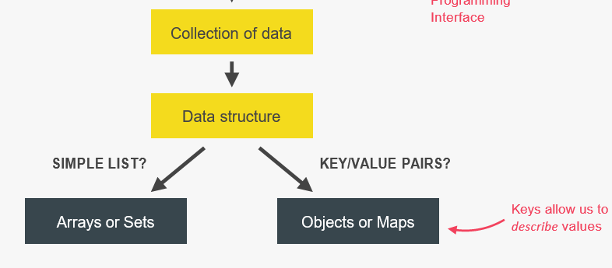

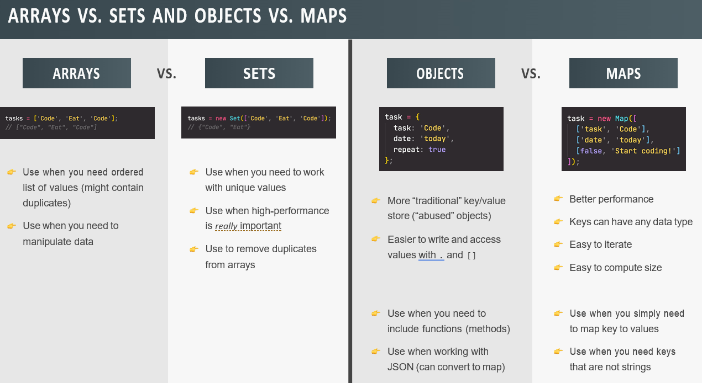

**String**

**Split:** allows us to split the string into different part.

console.log('a+very+nice+string'.split('+'));

["a", "very", "nice", "string"]

console.log('Jonas Schmedtmann'.split(' '));

["Jonas", "Schmedtmann"]

**Join:** join() method returns the array as a string.

The elements will be separated by a specific operator. The default separator is comma(,)

Note: This method will not change the original array.

const [firstName, lastName] = 'Jonas Schmedtmann'.split(' ');

const newName = ['Mr.', firstName, lastName.toUpperCase()].join(' ');

console.log(newName); //Mr. Jonas SCHMEDTMANN

**Padding:**

const message = 'Go to gate 23!';

console.log(message.padStart(20, '+').padEnd(30, '+'));

console.log('Jonas'.padStart(20, '+').padEnd(30, '+'));

++++++Go to gate 23!++++++++++

+++++++++++++++Jonas++++++++++

**Repeat:** It will repeat the string. For the no. as passed in argument.

const message2 = 'Bad waether... All Departues Delayed... ';

console.log(message2.repeat(5));

Bad waether... All Departues Delayed... Bad waether... All Departues Delayed... Bad waether... All Departues Delayed... Bad waether... All Departues Delayed... Bad waether... All Departues Delayed..

**toUpperCase() & toLowerCase()**:

const airline = 'TAP Air Portugal';

console.log(airline.toLowerCase());

console.log(airline.toUpperCase());

// **Fix capitalization in name**

const passenger = 'jOnAS'; // Jonas

const passengerLower = passenger.toLowerCase();

const passengerCorrect =

passengerLower[0].toUpperCase() + passengerLower.slice(1);

console.log(passengerCorrect); //Jonas

**passengerLower.slice(1)**

**"onas"**

**Replace:** replace the character with a new character which is passed in argument

const priceGB = '288,97£';

const priceUS = priceGB.replace('£', '$').replace(',', '.');

console.log(priceUS); //288.97$

**Boolean:**

const plane = 'Airbus A320neo';

console.log(plane.includes('A320')); //true

console.log(plane.includes('Boeing')); //false

console.log(plane.startsWith('Airb')); //true

**Working with String**

const airline = 'TAP Air Portugal';

const plane = 'A320';

console.log(plane[0]); //A

console.log(plane[1]); //3

console.log(plane[2]); //2

console.log('B737'[0]); //B

console.log(airline.length); //16

console.log('B737'.length); //4

console.log(airline.indexOf('r')); //6

console.log(airline.lastIndexOf('r')); //10

console.log(airline.indexOf('portugal')); //-1(because not available)

console.log(airline.slice(4)); //Air Portugal

console.log(airline.slice(4, 7)); //Air

console.log(airline.slice(0, airline.indexOf(' '))); //TAP

console.log(airline.slice(airline.lastIndexOf(' ') + 1)); //Portugal

console.log(airline.slice(-2)); //al

console.log(airline.slice(1, -1)); //AP Air Portuga

console.log(new String('jonas')); //String {"jonas"}

console.log(typeof new String('jonas')); //Object

console.log(typeof new String('jonas').slice(1)); //String

// **Maps: Iteration**

const question = new Map([

['question', 'What is the best programming language in the world?'],

[1, 'C'],

[2, 'Java'],

[3, 'JavaScript'],

['correct', 3],

[true, 'Correct 🎉'],

[false, 'Try again!'],

]);

console.log(question);

//object

const weekdays = ['mon', 'tue', 'wed', 'thu', 'fri', 'sat', 'sun'];

const openingHours = {

[weekdays[3]]: {

open: 12,

close: 22,

},

[weekdays[4]]: {

open: 11,

close: 23,

},

[weekdays[5]]: {

open: 0, // Open 24 hours

close: 24,

},

};

// **Convert object to map**

console.log(Object.entries(openingHours));

const hoursMap = new Map(Object.entries(openingHours));

console.log(hoursMap);

//**Iterate to Map**

console.log(question.get('question'));

for (const [key, value] of question) {

if (typeof key === 'number') console.log(`Answer ${key}: ${value}`);

}

// **Convert map to array**

console.log([...question]);

// console.log(question.entries());

console.log([...question.keys()]);

console.log([...question.values()]);

// **Maps: Fundamentals**

const rest = new Map();

rest.set('name', 'Classico Italiano');

rest.set(1, 'Firenze, Italy');

console.log(rest.set(2, 'Lisbon, Portugal'));

rest

.set('categories', ['Italian', 'Pizzeria', 'Vegetarian', 'Organic'])

.set('open', 11)

.set('close', 23)

.set(true, 'We are open :D')

.set(false, 'We are closed :(');

console.log(rest.get('name'));

console.log(rest.get(true));

console.log(rest.get(1));

const time = 8;

console.log(rest.get(time > rest.get('open') && time < rest.get('close')));

console.log(rest.has('categories')); //true

rest.delete(2);

rest.clear();

const arr = [1, 2];

rest.set(arr, 'Test');

console.log(rest);

console.log(rest.size);

console.log(rest.get(arr));

// **Sets**

const ordersSet = new Set([

'Pasta',

'Pizza',

'Pizza',

'Risotto',

'Pasta',

'Pizza',

]);

console.log(ordersSet); //pasta,pizza,risotto

console.log(new Set('Jonas')); //j,o,n,a,s

console.log(ordersSet.size); //3

console.log(ordersSet.has('Pizza')); //true

console.log(ordersSet.has('Bread')); //false

ordersSet.add('Garlic Bread');

ordersSet.add('Garlic Bread');

//Set(4) {"Pasta", "Pizza", "Risotto", "Garlic Bread"}

ordersSet.delete('Risotto');

ordersSet.clear();

console.log(ordersSet);

//**Iteration**

for (const order of ordersSet) console.log(order);

//**Assigning to another set/array**

const staff = ['Waiter', 'Chef', 'Waiter', 'Manager', 'Chef', 'Waiter'];

const staffUnique = [...new Set(staff)];

console.log(staffUnique);

console.log(new Set('jonasschmedtmann').size); //11

// **Looping Objects: Object Keys, Values, and Entries**

const weekdays = ['mon', 'tue', 'wed', 'thu', 'fri', 'sat', 'sun'];

const openingHours = {

[weekdays[3]]: {

open: 12,

close: 22,

},

[weekdays[4]]: {

open: 11,

close: 23,

},

[weekdays[5]]: {

open: 0, // Open 24 hours

close: 24,

},

};

// Property NAMES

const properties = Object.keys(openingHours);

console.log(properties);

let openStr = `We are open on ${properties.length} days: `;

for (const day of properties) {

openStr += `${day}, `;

}

console.log(openStr);

// Property VALUES

const values = Object.values(openingHours);

console.log(values);

// Entire object

const entries = Object.entries(openingHours);

console.log(entries);

// [key, value]

for (const [day, { open, close }] of entries) {

console.log(`On ${day} we open at ${open} and close at ${close}`);

}

// **Optional Chaining**

if (restaurant.openingHours && restaurant.openingHours.mon)

console.log(restaurant.openingHours.mon.open);

// WITH optional chaining

console.log(restaurant.openingHours.mon?.open);

console.log(restaurant.openingHours?.mon?.open);

//object

const restaurant = {

name: 'Classico Italiano',

location: 'Via Angelo Tavanti 23, Firenze, Italy',

categories: ['Italian', 'Pizzeria', 'Vegetarian', 'Organic'],

starterMenu: ['Focaccia', 'Bruschetta', 'Garlic Bread', 'Caprese Salad'],

mainMenu: ['Pizza', 'Pasta', 'Risotto'],

// ES6 enhanced object literals

openingHours,

order(starterIndex, mainIndex) {

return [this.starterMenu[starterIndex], this.mainMenu[mainIndex]];

},

orderDelivery({ starterIndex = 1, mainIndex = 0, time = '20:00', address }) {

console.log(

`Order received! ${this.starterMenu[starterIndex]} and ${this.mainMenu[mainIndex]} will be delivered to ${address} at ${time}`

);

},

orderPasta(ing1, ing2, ing3) {

console.log(

`Here is your declicious pasta with ${ing1}, ${ing2} and ${ing3}`

);

},

orderPizza(mainIngredient, ...otherIngredients) {

console.log(mainIngredient);

console.log(otherIngredients);

},

};

// Example

const days = ['mon', 'tue', 'wed', 'thu', 'fri', 'sat', 'sun'];

for (const day of days) {

const open = restaurant.openingHours[day]?.open ?? 'closed';

console.log(`On ${day}, we open at ${open}`);

}

// Methods

console.log(restaurant.order?.(0, 1) ?? 'Method does not exist');

console.log(restaurant.orderRisotto?.(0, 1) ?? 'Method does not exist');

// Arrays

const users = [{ name: 'Jonas', email: 'hello@jonas.io' }];

// const users = [];

console.log(users[0]?.name ?? 'User array empty');

if (users.length > 0) console.log(users[0].name);

else console.log('user array empty');

// **The for-of Loop**

const menu = [...restaurant.starterMenu, ...restaurant.mainMenu];

for (const item of menu) console.log(item);

for (const [i, el] of menu.entries()) {

console.log(`${i + 1}: ${el}`);

}

// console.log([...menu.entries()]);

// **The Nullish Coalescing Operator**

restaurant.numGuests = 0;

const guests = restaurant.numGuests || 10;

console.log(guests);

// Nullish: null and undefined (NOT 0 or '')

const guestCorrect = restaurant.numGuests ?? 10;

console.log(guestCorrect);

// **Short Circuiting (&& and ||)**

console.log('---- OR ----');

// Use ANY data type, return ANY data type, short-circuiting

console.log(3 || 'Jonas');

console.log('' || 'Jonas');

console.log(true || 0);

console.log(undefined || null);

console.log(undefined || 0 || '' || 'Hello' || 23 || null);

restaurant.numGuests = 0;

const guests1 = restaurant.numGuests ? restaurant.numGuests : 10;

console.log(guests1);

const guests2 = restaurant.numGuests || 10;

console.log(guests2);

console.log('---- AND ----');

console.log(0 && 'Jonas');

console.log(7 && 'Jonas');

console.log('Hello' && 23 && null && 'jonas');

// Practical example

if (restaurant.orderPizza) {

restaurant.orderPizza('mushrooms', 'spinach');

}

restaurant.orderPizza && restaurant.orderPizza('mushrooms', 'spinach');

// **Rest Pattern and Parameters**

**// 1) Destructuring**

// SPREAD, because on RIGHT side of =

const arr = [1, 2, ...[3, 4]];

// REST, because on LEFT side of =

const [a, b, ...others] = [1, 2, 3, 4, 5];

console.log(a, b, others);

const [pizza, , risotto, ...otherFood] = [

...restaurant.mainMenu,

...restaurant.starterMenu,

];

console.log(pizza, risotto, otherFood);

// Objects

const { sat, ...weekdays } = restaurant.openingHours;

console.log(weekdays);

// 2) **Functions**

const add = function (...numbers) {

let sum = 0;

for (let i = 0; i < numbers.length; i++) sum += numbers[i];

console.log(sum);

};

add(2, 3);

add(5, 3, 7, 2);

add(8, 2, 5, 3, 2, 1, 4);

const x = [23, 5, 7];

add(...x);

restaurant.orderPizza('mushrooms', 'onion', 'olives', 'spinach');

restaurant.orderPizza('mushrooms');

// **The Spread Operator (...)**

const arr = [7, 8, 9];

const badNewArr = [1, 2, arr[0], arr[1], arr[2]];

console.log(badNewArr);

const newArr = [1, 2, ...arr];

console.log(newArr);

console.log(...newArr);

console.log(1, 2, 7, 8, 9);

const newMenu = [...restaurant.mainMenu, 'Gnocci'];

console.log(newMenu);

// Copy array

const mainMenuCopy = [...restaurant.mainMenu];

// Join 2 arrays

const menu = [...restaurant.starterMenu, ...restaurant.mainMenu];

console.log(menu);

// Objects

const newRestaurant = { foundedIn: 1998, ...restaurant, founder: 'Guiseppe' };

console.log(newRestaurant);

const restaurantCopy = { ...restaurant };

restaurantCopy.name = 'Ristorante Roma';

console.log(restaurantCopy.name);

console.log(restaurant.name);

// **Destructuring Objects**

restaurant.orderDelivery({

time: '22:30',

address: 'Via del Sole, 21',

mainIndex: 2,

starterIndex: 2,

});

restaurant.orderDelivery({

address: 'Via del Sole, 21',

starterIndex: 1,

});

const { name, openingHours, categories } = restaurant;

console.log(name, openingHours, categories);

const {

name: restaurantName,

openingHours: hours,

categories: tags,

} = restaurant;

console.log(restaurantName, hours, tags);

// Default values

const { menu = [], starterMenu: starters = [] } = restaurant;

console.log(menu, starters);

// Mutating variables

let a = 111;

let b = 999;

const obj = { a: 23, b: 7, c: 14 };

({ a, b } = obj);

console.log(a, b);

// Nested objects

const {

fri: { open: o, close: c },

} = openingHours;

console.log(o, c);

// **Destructuring Arrays**

const arr = [2, 3, 4];

const a = arr[0];

const b = arr[1];

const c = arr[2];

const [x, y, z] = arr;

console.log(x, y, z);

console.log(arr);

let [main, , secondary] = restaurant.categories;

console.log(main, secondary);

// Switching variables

// const temp = main;

// main = secondary;

// secondary = temp;

// console.log(main, secondary);

[main, secondary] = [secondary, main];

console.log(main, secondary);

// Receive 2 return values from a function

const [starter, mainCourse] = restaurant.order(2, 0);

console.log(starter, mainCourse);

// Nested destructuring

const nested = [2, 4, [5, 6]];

// const [i, , j] = nested;

const [i, , [j, k]] = nested;

console.log(i, j, k);

// Default values

const [p = 1, q = 1, r = 1] = [8, 9];

console.log(p, q, r);

**Destructuring:** Destructuring is an ES6 feature and it’s basically a way of unpacking values from an array or an object into separate variables.

-or-Destructuring is a way of breaking down a complex data structure variable into a smaller data structure.

**Spread Operator:** Use basically to expand an array into all it’s element.

-so basically unpacking all the array element at one.

-we can use this spread operator whenever we would otherwise write multiple values separated by commas.

-**USE**-1.Shallow copies of array

2.Merge two array together.

-Spread operator works on all arrays but not on all array just with array iterable.

-Iterable are things like all arrays, strings, maps or sets but not objects.

-We can only use spread operators when building an array, or when we pass values into a function.

**Rest Syntax & Rest Parameter**:(Opposite of spread)

-**Rest syntax** is taking multiple numbers or multiple values and then pack them up all into one array.

-**Rest pattern** can be used where we should write variable names, separated by commas and not values separated by commas.

**Short-circuiting(&&, ||):**

-In case of **OR** operator, short-circuiting means that if the first value is a truthy value, it will immediately return the first value.

-In case of **AND** operator short-circuiting, when the first value is falsy and then immediately returns that falsy value without even evaluating the second operand.

**Optional Chaining**: If a certain property does not exist, then undefined is returned immediately.

In ES6 two or more Data Structure are added that is **sets** and **maps.**

**Sets:** Just a collection of unique values. Can never have duplicate value.

-set can hold mixed data types

-set are iterable.

-set is different from array because.

-contain unique value

-order is irrelevant

-In set there is no indexes.

-There is no way of getting value out of set. That’s because if all values are unique, and if the order does not matter, then there is no point of retrieving value from set.

**Maps**:

-It is a data structure to map values to key.

-So just like object, data is stored in key value pair in maps.

-Difference between object and map is that in map, a key can have any type.

-In Object, the keys are basically always string.

**Strings:** Strings are just primitive.

-so why do they have methods? Shouldn’t be method only available to objects?

Ans: Whenever we call method on string, JS will convert the string primitive into string object behind the scene with the same content.

-And this process is called **Boxing**.

**Default Parameters:**

// **Default Parameters**

const bookings = [];

const createBooking = function (

flightNum,

numPassengers = 1,

price = 199 * numPassengers

) {

// ES5

// numPassengers = numPassengers || 1;

// price = price || 199;

const booking = {

flightNum,

numPassengers,

price,

};

console.log(booking);

bookings.push(booking);

};

createBooking('LH123');

createBooking('LH123', 2, 800);

**Argument works Value vs Reference:**

// **How Passing Arguments Works: Values vs. Reference**

const flight = 'LH234';

const jonas = {

name: 'Jonas Schmedtmann',

passport: 24739479284,

};

const checkIn = function (flightNum, passenger) {

flightNum = 'LH999';

passenger.name = 'Mr. ' + passenger.name;

if (passenger.passport === 24739479284) {

alert('Checked in');

} else {

alert('Wrong passport!');

}

};

// checkIn(flight, jonas);

// console.log(flight);

// console.log(jonas);

// Is the same as doing...

// const flightNum = flight;

// const passenger = jonas;

-**Val:** Just primitive type, as we passed that value into the function, then the flight num value here is basically a copy of that original value.

-so flightNum contains the copy and not simply the original value of the flight variable.

//flightNum=flight(it will not get reflected outside the function)

-**Ref:** When we pass a reference type to the function, what is copied is really just a reference to the object in the memory heap.

-**Summary:**

* Passing a primitive type to a function is really just the same as creating a copy like this, outside the function. So the value is simply copied.
* On the other hand, when we pass an object to a function, it is just like copying an object like this. So, whatever we change in copy will also happen in then original.

-const flightNum = flight; //primitive

-const passenger = Jonas; //object

-JS, does not have passing by reference, only passing by value even though it’s look like passing by reference.

-But as we look we passed object and that looks like pass by reference, but it’s not. It’s just simply a value that contains a memory address.

-Basically, we pass a reference to the function, but we do not pass by reference.

**Why JS uses callback function all the time?**

-Split of code into more reusable part

-callback function allows us to create abstraction

// **Functions Accepting Callback Functions**

const oneWord = function (str) {

return str.replace(/ /g, '').toLowerCase();

};

const upperFirstWord = function (str) {

const [first, ...others] = str.split(' ');

return [first.toUpperCase(), ...others].join(' ');

};

// **Higher-order function**

const transformer = function (str, fn) {

console.log(`Original string: ${str}`);

console.log(`Transformed string: ${fn(str)}`);

console.log(`Transformed by: ${fn.name}`);

};

transformer('JavaScript is the best!', upperFirstWord);

transformer('JavaScript is the best!', oneWord);

// JS uses callbacks all the time

const high5 = function () {

console.log('👋');

};

document.body.addEventListener('click', high5);

['Jonas', 'Martha', 'Adam'].forEach(high5);

**First-class Vs High-Order Function:**

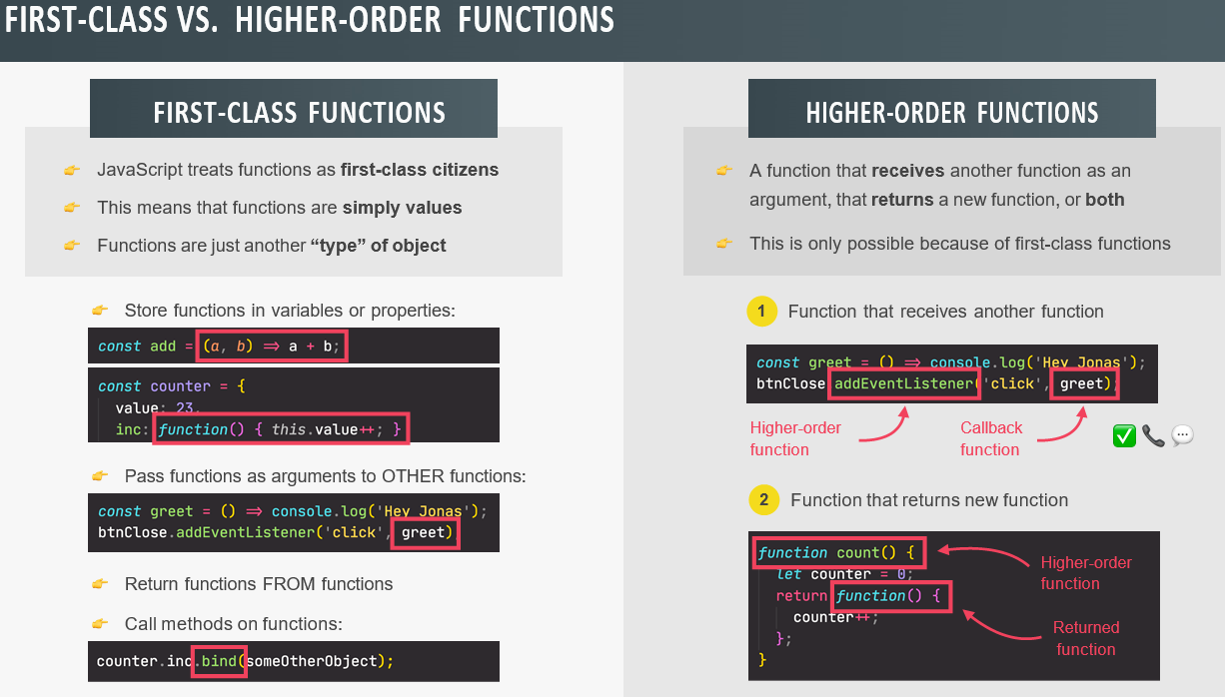

**First-Class Function:**

-JS treats function as first-class function

-This means that function are simply values

-Functions are just another “type” of objects

* Store function in variable or properties
* Pass function as arguments to OTHER function
* Return function FROM function
* Call methods on function

**Higher-Order Function:**

-A function that receives another function as an argument, that returns a new function, or both

-This is only possible because of first-class function

**Note:** Specifying part of arguments beforehand is actually a common pattern called **Partial Application**.

// **Functions Returning Functions**

const greet = function (greeting) {

return function (name) {

console.log(`${greeting} ${name}`);

};

};

const greeterHey = greet('Hey');

greeterHey('Jonas');

greeterHey('Steven');

greet('Hello')('Jonas');

// Challenge

const greetArr = greeting => name => console.log(`${greeting} ${name}`);

greetArr('Hi')('Jonas');

**Function Call:**

In JavaScript all functions are object methods.

If a function is not a method of a JavaScript object, it is a function of the global object

**The this Keyword**

In a function definition, this refers to the "owner" of the function.

call() method is a predefined JavaScript method.

It can be used to invoke (call) a method with an owner object as an argument (parameter).

With call(), an object can use a method belonging to another object.

var person = {  
  **fullName**: function() {  
    return this.firstName + " " + this.lastName;  
  }  
}  
var person1 = {  
  firstName:"John",  
  lastName: "Doe"  
}  
var person2 = {  
  firstName:"Mary",  
  lastName: "Doe"  
}  
person.fullName.call(**person1**); //john doe

//call method with argument

var person = {  
  fullName: function(city, country) {  
    return this.firstName + " " + this.lastName + "," + city + "," + country;  
  }  
}  
var person1 = {  
  firstName:"John",  
  lastName: "Doe"  
}  
person.fullName.call(person1, "Oslo", "Norway");

// **The call and apply Methods**

const lufthansa = {

airline: 'Lufthansa',

iataCode: 'LH',

bookings: [],

// book: function() {}

book(flightNum, name) {

console.log(

`${name} booked a seat on ${this.airline} flight ${this.iataCode}${flightNum}`

);

this.bookings.push({ flight: `${this.iataCode}${flightNum}`, name });

},

};

lufthansa.book(239, 'Jonas Schmedtmann');

lufthansa.book(635, 'John Smith');

const eurowings = {

airline: 'Eurowings',

iataCode: 'EW',

bookings: [],

};

const book = lufthansa.book;

// Does NOT work

// book(23, 'Sarah Williams');

// Call method

book.call(eurowings, 23, 'Sarah Williams');

console.log(eurowings);

book.call(lufthansa, 239, 'Mary Cooper');

console.log(lufthansa);

const swiss = {

airline: 'Swiss Air Lines',

iataCode: 'LX',

bookings: [],

};

book.call(swiss, 583, 'Mary Cooper');

The apply() method is similar to the call() method

var person = {  
  fullName: function() {  
    return this.firstName + " " + this.lastName;  
  }  
}  
var person1 = {  
  firstName: "Mary",  
  lastName: "Doe"  
}  
person.fullName.apply(person1);  // Will return "Mary Doe"

## The Difference Between call() and apply()

The difference is:

The call() method takes arguments **separately**.

The apply() method takes arguments as an **array**.

apply() method accepts arguments in an array

var person = {  
  fullName: function(city, country) {  
    return this.firstName + " " + this.lastName + "," + city + "," + country;  
  }  
}  
var person1 = {  
  firstName:"John",  
  lastName: "Doe"  
}  
person.fullName.apply(person1, ["Oslo", "Norway"]);

// **Apply method**

const flightData = [583, 'George Cooper'];

book.apply(swiss, flightData);

console.log(swiss);

book.call(swiss, ...flightData);

**Bind Method:** The **bind()** method creates a new function that, when called, has its this keyword set to the provided value, with a given sequence of arguments preceding any provided when the new function is called.

const module = {

x: 42,

getX: function() {

return this.x;

}

};

const unboundGetX = module.getX;

console.log(unboundGetX()); // The function gets invoked at the global scope

// expected output: undefined

const boundGetX = unboundGetX.bind(module);

console.log(boundGetX());

// expected output: 42

// **The bind Method**

// book.call(eurowings, 23, 'Sarah Williams');

const bookEW = book.bind(eurowings);

const bookLH = book.bind(lufthansa);

const bookLX = book.bind(swiss);

bookEW(23, 'Steven Williams');

const bookEW23 = book.bind(eurowings, 23);

bookEW23('Jonas Schmedtmann');

bookEW23('Martha Cooper');

// With Event Listeners

lufthansa.planes = 300;

lufthansa.buyPlane = function () {

console.log(this);

this.planes++;

console.log(this.planes);

};

// lufthansa.buyPlane();

document

.querySelector('.buy')

.addEventListener('click', lufthansa.buyPlane.bind(lufthansa));

// Partial application

const addTax = (rate, value) => value + value * rate;

console.log(addTax(0.1, 200));

const addVAT = addTax.bind(null, 0.23);

// addVAT = value => value + value * 0.23;

console.log(addVAT(100));

console.log(addVAT(23));

const addTaxRate = function (rate) {

return function (value) {

return value + value * rate;

};

};

const addVAT2 = addTaxRate(0.23);

console.log(addVAT2(100));

console.log(addVAT2(23));

**Closure:** Closure makes a function remember all the variable that existed at the function birthplace essentially.

-Any function always has access to the variable environment of the execution context in which the function was created.

-Thanks to the closure, a function does not lose connection to variable that existed at the function birthplace.

-Closure has priority over the scope chain.

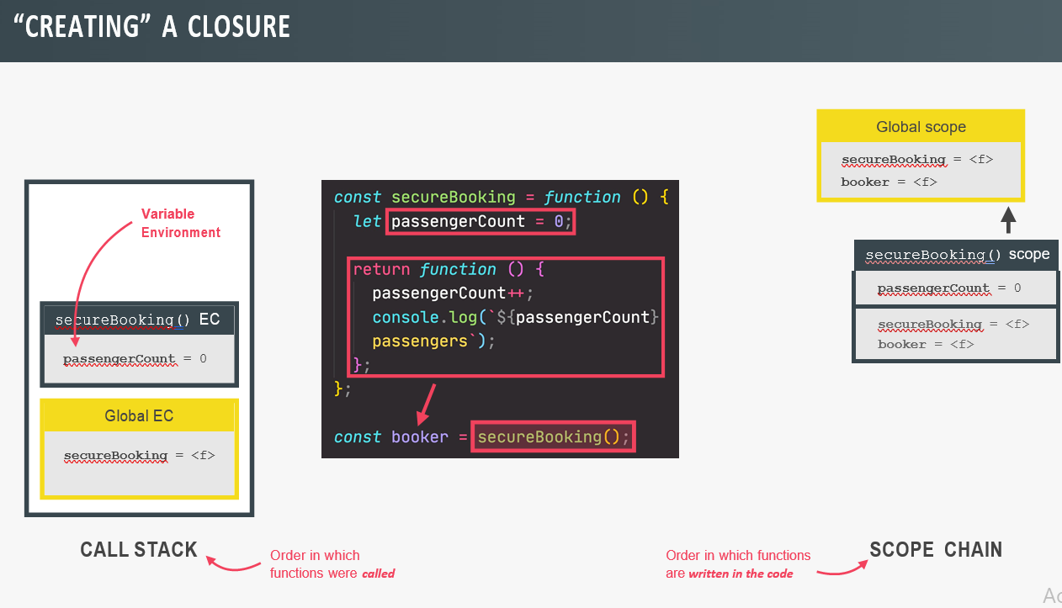

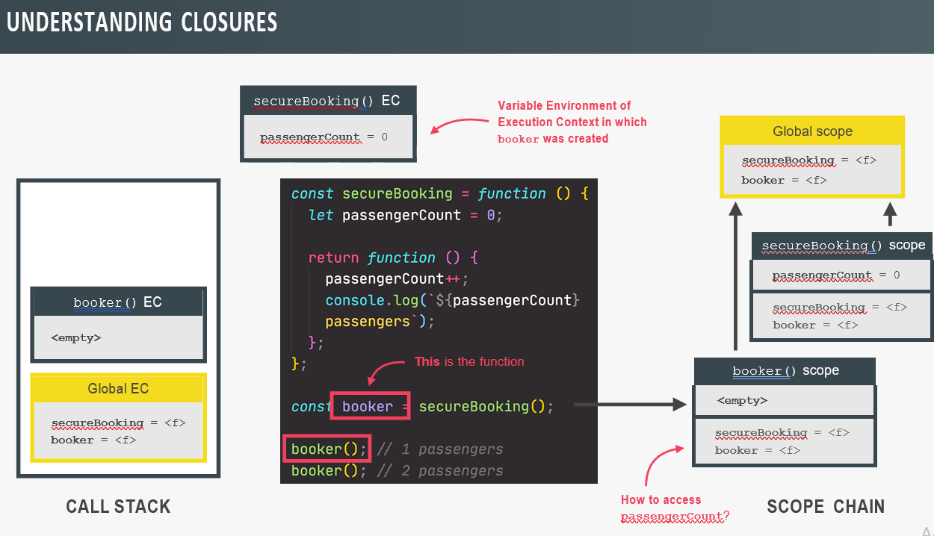

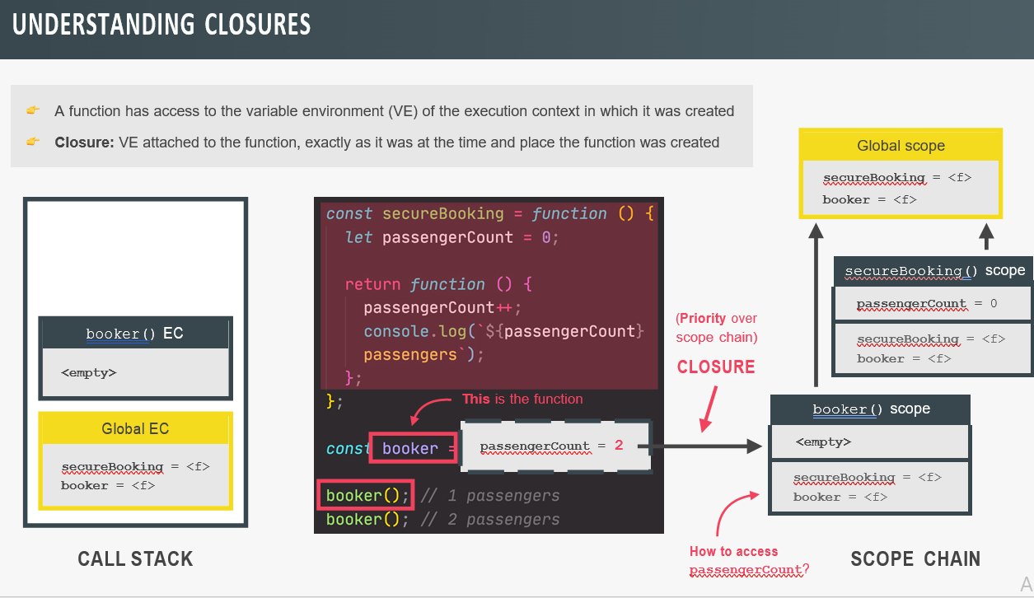

// **Closures**

const secureBooking = function () {

let passengerCount = 0;

return function () {

passengerCount++;

console.log(`${passengerCount} passengers`);

};

};

const booker = secureBooking();

booker();

booker();

booker();

console.dir(booker);

-A closure is the closed-over variable environment of the execution context in which a function was created, even after that execution context is gone.

🡪(LF)A closure gives a function access to all the variable of its function, even after that parent function has returned. The function keeps a reference to its outer scope, which preserves the scope chain throughout time.

///////////////////////////////////////

// **More Closure Examples**

// Example 1

let f;

const g = function () {

const a = 23;

f = function () {

console.log(a * 2);

};

};

const h = function () {

const b = 777;

f = function () {

console.log(b * 2);

};

};

g();

f();

console.dir(f);

// Re-assigning f function

h();

f();

console.dir(f);

// Example 2

const boardPassengers = function (n, wait) {

const perGroup = n / 3;

setTimeout(function () {

console.log(`We are now boarding all ${n} passengers`);

console.log(`There are 3 groups, each with ${perGroup} passengers`);

}, wait * 1000);

console.log(`Will start boarding in ${wait} seconds`);

};

const perGroup = 1000;

boardPassengers(180, 3);

**IIFE: Immediately Invoked Function Expression**

An **IIFE** (Immediately Invoked Function Expression) is a [JavaScript](https://developer.mozilla.org/en-US/docs/Glossary/JavaScript) [function](https://developer.mozilla.org/en-US/docs/Glossary/Function) that runs as soon as it is defined. (function () {

statements

})();

It is a design pattern which is also known as a [Self-Executing Anonymous Function](https://developer.mozilla.org/en-US/docs/Glossary/Self-Executing_Anonymous_Function) and contains two major parts:

1. The first is the anonymous function with lexical scope enclosed within the [Grouping Operator](https://developer.mozilla.org/en-US/docs/Web/JavaScript/Reference/Operators/Grouping) (). This prevents accessing variables within the IIFE idiom as well as polluting the global scope.
2. The second part creates the immediately invoked function expression () through which the JavaScript engine will directly interpret the function.

// **Immediately Invoked Function Expressions (IIFE)**

const runOnce = function () {

console.log('This will never run again');

};

runOnce();

// IIFE

(function () {

console.log('This will never run again');

const isPrivate = 23;

})();

// console.log(isPrivate);

(() => console.log('This will ALSO never run again'))();

{

const isPrivate = 23;

var notPrivate = 46;

}

// console.log(isPrivate);

console.log(notPrivate);

**Array:**

**Basic Array Method:**

const movements = [200, 450, -400, 3000, -650, -130, 70, 1300];

**Slice:** Extract part of any array, but without changing the original array.

let arr = ['a', 'b', 'c', 'd', 'e'];

// SLICE

console.log(arr.slice(2));

console.log(arr.slice(2, 4));

console.log(arr.slice(-2));

console.log(arr.slice(-1));

console.log(arr.slice(1, -2));

console.log(arr.slice());

console.log([...arr]);

**Splice:** Works exactly same as slice, but fundamental difference is it does change the original array.

-It mutate the array.

-It doesn’t interest us, it just interest us when we want to delete one or more element from an array using splice.

// SPLICE

// console.log(arr.splice(2));

arr.splice(-1);

console.log(arr);

arr.splice(1, 2);

console.log(arr);

**Reverse:** Reverse the array and does actually mutate the array.

// REVERSE

arr = ['a', 'b', 'c', 'd', 'e'];

const arr2 = ['j', 'i', 'h', 'g', 'f'];

console.log(arr2.reverse());

console.log(arr2);

**Concat:** Concatenate two array and does not mutate original array.

// CONCAT

const letters = arr.concat(arr2);

console.log(letters);

console.log([...arr, ...arr2]);

**Join:**

// JOIN

console.log(letters.join(' - '));

**ForEach:** movements.forEach(func(){})

-What forEach method does is to loop over the array, and in each iteration it will execute this callback function here.

// **Looping Arrays: forEach**

const movements = [200, 450, -400, 3000, -650, -130, 70, 1300];

// for (const movement of movements) {

for (const [i, movement] of movements.entries()) {

if (movement > 0) {

console.log(`Movement ${i + 1}: You deposited ${movement}`);

} else {

console.log(`Movement ${i + 1}: You withdrew ${Math.abs(movement)}`);

}

}

console.log('---- FOREACH ----');

movements.forEach(function (mov, i, arr) {

if (mov > 0) {

console.log(`Movement ${i + 1}: You deposited ${mov}`);

} else {

console.log(`Movement ${i + 1}: You withdrew ${Math.abs(mov)}`);

}

});

// 0: function(200)

// 1: function(450)

// 2: function(400)

// ...

///////////////////////////////////////

// **forEach With Maps and Sets**

// **Map**

const currencies = new Map([

['USD', 'United States dollar'],

['EUR', 'Euro'],

['GBP', 'Pound sterling'],

]);

currencies.forEach(function (value, key, map) {

console.log(`${key}: ${value}`);

});

// **Set**

const currenciesUnique = new Set(['USD', 'GBP', 'USD', 'EUR', 'EUR']);

console.log(currenciesUnique);

currenciesUnique.forEach(function (value, _, map) {

console.log(`${value}: ${value}`);

});

**Note:** You cannot break out of forEach loop, but can of for-of loop.

**Map:** Map creates a brand new array based on the original array.

-Map method takes an array, loop over that array and in each iteration, it applies an callback function that we specify in our code to the current array element.

-Better than forEach

-Map return a new array containing the result of applying an operation on all original array element.

// **The map Method**

const eurToUsd = 1.1;

// const movementsUSD = movements.map(function (mov) {

// return mov * eurToUsd;

// });

const movementsUSD = movements.map(mov => mov * eurToUsd);

console.log(movements);

console.log(movementsUSD);

const movementsUSDfor = [];

for (const mov of movements) movementsUSDfor.push(mov * eurToUsd);

console.log(movementsUSDfor);

const movementsDescriptions = movements.map(

(mov, i) =>

`Movement ${i + 1}: You ${mov > 0 ? 'deposited' : 'withdrew'} ${Math.abs(

mov

)}`

);

console.log(movementsDescriptions);

**Filter:** Used to filter for element in the original array which satisfy certain condition.

-Filter returns a new array containing the array element that passes a specific test condition.

// **The filter Method**

const deposits = movements.filter(function (mov, i, arr) {

return mov > 0;

});

console.log(movements);

console.log(deposits);

const depositsFor = [];

for (const mov of movements) if (mov > 0) depositsFor.push(mov);

console.log(depositsFor);

const withdrawals = movements.filter(mov => mov < 0);

console.log(withdrawals);

**Reduce:** Used to boil down all the elements of the original array into one single value. E.g.: adding all the elements together.

// **The reduce Method**

console.log(movements);

// accumulator -> SNOWBALL

// const balance = movements.reduce(function (acc, cur, i, arr) {

// console.log(`Iteration ${i}: ${acc}`);

// return acc + cur;

// }, 0);

const balance = movements.reduce((acc, cur) => acc + cur, 0);

console.log(balance);

let balance2 = 0;

for (const mov of movements) balance2 += mov;

console.log(balance2);

// Maximum value

const max = movements.reduce((acc, mov) => {

if (acc > mov) return acc;

else return mov;

}, movements[0]);

console.log(max);

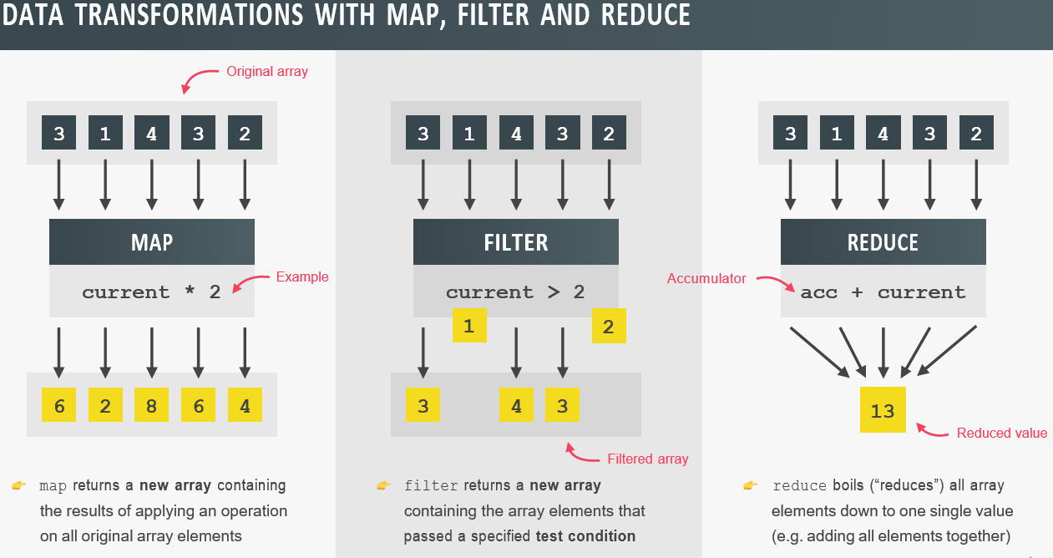

// **The Magic of Chaining Methods**

const eurToUsd = 1.1;

console.log(movements);

// PIPELINE

const totalDepositsUSD = movements

.filter(mov => mov > 0)

.map((mov, i, arr) => {

// console.log(arr);

return mov * eurToUsd;

})

// .map(mov => mov * eurToUsd)

.reduce((acc, mov) => acc + mov, 0);

console.log(totalDepositsUSD);

**Find:** Use find method to retrieve one element, of an array based on a condition.

-It will not return the array, but will return the first element that satisfy the condition.

// **The find Method**

const firstWithdrawal = movements.find(mov => mov < 0);

console.log(movements);

console.log(firstWithdrawal);

console.log(accounts);

const account = accounts.find(acc => acc.owner === 'Jessica Davis');

console.log(account);

**Some:** The some() method checks if any of the elements in an array pass a test

The some() method executes the function once for each element present in the array:

* If it finds an array element where the function returns a *true* value, some() returns true (and does not check the remaining values)
* Otherwise it returns false

**Note:** some() does not execute the function for array elements without values.

**Note:** some() does not change the original array.

**Every:** The every() method checks if all elements in an array pass a test

// **some and every**

console.log(movements);

// EQUALITY

console.log(movements.includes(-130));

// SOME: CONDITION

console.log(movements.some(mov => mov === -130));

const anyDeposits = movements.some(mov => mov > 0);

console.log(anyDeposits);

// EVERY

console.log(movements.every(mov => mov > 0));

console.log(account4.movements.every(mov => mov > 0));

// Separate callback

const deposit = mov => mov > 0;

console.log(movements.some(deposit));

console.log(movements.every(deposit));

console.log(movements.filter(deposit));

**Flat:** The **flat()** method creates a new array with all sub-array elements concatenated into it recursively up to the specified depth.

const arr1 = [0, 1, 2, [3, 4]];

console.log(arr1.flat());

// expected output: [0, 1, 2, 3, 4]

const arr2 = [0, 1, 2, [[[3, 4]]]];

console.log(arr2.flat(2));

// expected output: [0, 1, 2, [3, 4]]

console.log(arr2.flat(3));

// expected output: [0, 1, 2, 3, 4]

**FlatMap:** The **flatMap()** method returns a new array formed by applying a given callback function to each element of the array, and then flattening the result by one level. It is identical to a [map()](https://developer.mozilla.org/en-US/docs/Web/JavaScript/Reference/Global_Objects/Array/map) followed by a [flat()](https://developer.mozilla.org/en-US/docs/Web/JavaScript/Reference/Global_Objects/Array/flat) of depth 1, but slightly more efficient than calling those two methods separately.

// **flat and flatMap**

const arr = [[1, 2, 3], [4, 5, 6], 7, 8];

console.log(arr.flat());

const arrDeep = [[[1, 2], 3], [4, [5, 6]], 7, 8];

console.log(arrDeep.flat(2));

// flat

const overalBalance = accounts

.map(acc => acc.movements)

.flat()

.reduce((acc, mov) => acc + mov, 0);

console.log(overalBalance);

// flatMap

const overalBalance2 = accounts

.flatMap(acc => acc.movements)

.reduce((acc, mov) => acc + mov, 0);

console.log(overalBalance2);

// **Sorting Arrays**

// Strings

const owners = ['Jonas', 'Zach', 'Adam', 'Martha'];

console.log(owners.sort());

console.log(owners);

// Numbers

console.log(movements);

// return < 0, A, B (keep order)

// return > 0, B, A (switch order)

// Ascending

// movements.sort((a, b) => {

// if (a > b) return 1;

// if (a < b) return -1;

// });

movements.sort((a, b) => a - b);

console.log(movements);

// Descending

// movements.sort((a, b) => {

// if (a > b) return -1;

// if (a < b) return 1;

// });

movements.sort((a, b) => b - a);

console.log(movements);

**Fill:** The fill() method fills the specified elements in an array with a static value.

You can specify the position of where to start and end the filling. If not specified, all elements will be filled.

**Note:** this method overwrites the original array.

// **More Ways of Creating and Filling Arrays**

const arr = [1, 2, 3, 4, 5, 6, 7];

console.log(new Array(1, 2, 3, 4, 5, 6, 7));

// Empty arrays + fill method

const x = new Array(7);

console.log(x);

// console.log(x.map(() => 5));

x.fill(1, 3, 5);

x.fill(1);

console.log(x);

arr.fill(23, 2, 6);

console.log(arr);

// Array.from

const y = Array.from({ length: 7 }, () => 1);

console.log(y);

const z = Array.from({ length: 7 }, (_, i) => i + 1);

console.log(z);

labelBalance.addEventListener('click', function () {

const movementsUI = Array.from(

document.querySelectorAll('.movements__value'),

el => Number(el.textContent.replace('€', ''))

);

console.log(movementsUI);

const movementsUI2 = [...document.querySelectorAll('.movements__value')];

});

**From:** The **Array.from()** static method creates a new, shallow-copied Array instance from an array-like or iterable object.

The Array.from() method returns an Array object from any object with a length property or an iterable object.

Array.from(object, mapFunction, thisValue)

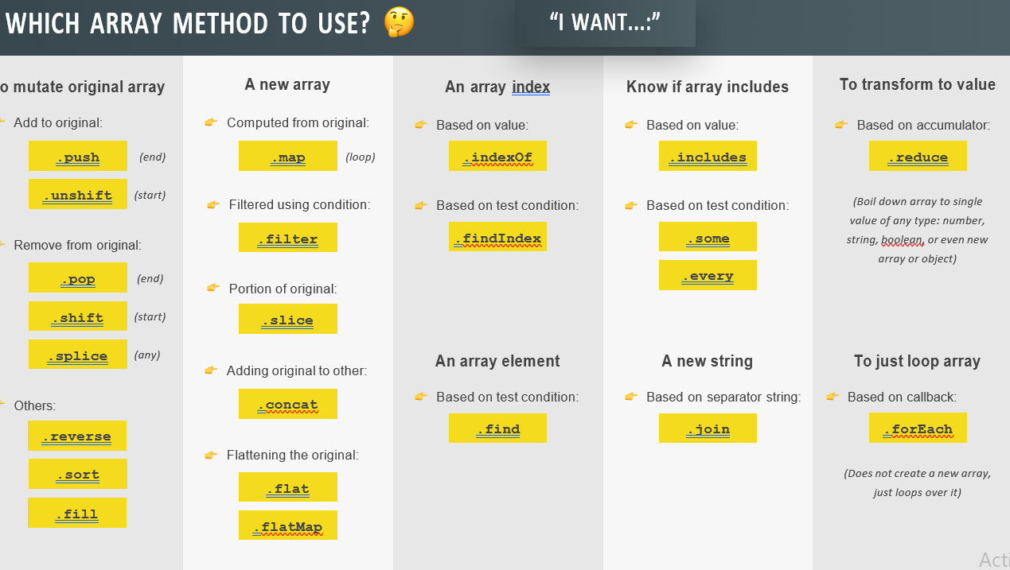

// **Converting and Checking Numbers**

console.log(23 === 23.0); //true

// Base 10 - 0 to 9. 1/10 = 0.1. 3/10 = 3.3333333

// Binary base 2 - 0 1

console.log(0.1 + 0.2); // 0.30000000000000004

console.log(0.1 + 0.2 === 0.3); //false

// Conversion

console.log(Number('23'));

console.log(+'23');

// Parsing

console.log(Number.parseInt('30px', 10)); //30

console.log(Number.parseInt('e23', 10)); //NaN

console.log(Number.parseInt(' 2.5rem ')); //2

console.log(Number.parseFloat(' 2.5rem ')); //2.5

// console.log(parseFloat(' 2.5rem '));

// Check if value is NaN

console.log(Number.isNaN(20)); //false

console.log(Number.isNaN('20')); //false

console.log(Number.isNaN(+'20X')); //true

console.log(Number.isNaN(23 / 0)); //false

// Checking if value is number

console.log(Number.isFinite(20)); //true

console.log(Number.isFinite('20')); //false

console.log(Number.isFinite(+'20X')); //false

console.log(Number.isFinite(23 / 0)); //false

console.log(Number.isInteger(23)); //true

console.log(Number.isInteger(23.0)); //true

console.log(Number.isInteger(23 / 0)); //false

// **Math and Rounding**

console.log(Math.sqrt(25));

console.log(25 ** (1 / 2));

console.log(8 ** (1 / 3));

console.log(Math.max(5, 18, 23, 11, 2));

console.log(Math.max(5, 18, '23', 11, 2));

console.log(Math.max(5, 18, '23px', 11, 2));

console.log(Math.min(5, 18, 23, 11, 2));

console.log(Math.PI * Number.parseFloat('10px') ** 2);

console.log(Math.trunc(Math.random() * 6) + 1);

const randomInt = (min, max) =>

Math.floor(Math.random() * (max - min) + 1) + min;

// 0...1 -> 0...(max - min) -> min...max

// console.log(randomInt(10, 20));

// **Rounding integers**

console.log(Math.round(23.3));

console.log(Math.round(23.9));

console.log(Math.ceil(23.3));

console.log(Math.ceil(23.9));

console.log(Math.floor(23.3));

console.log(Math.floor('23.9'));

console.log(Math.trunc(23.3));

console.log(Math.trunc(-23.3));

console.log(Math.floor(-23.3));

// **Rounding decimals**

console.log((2.7).toFixed(0));

console.log((2.7).toFixed(3));

console.log((2.345).toFixed(2));

console.log(+(2.345).toFixed(2));

///////////////////////////////////////

// **The Remainder Operator**

console.log(5 % 2);

console.log(5 / 2); // 5 = 2 * 2 + 1

console.log(8 % 3);

console.log(8 / 3); // 8 = 2 * 3 + 2

console.log(6 % 2);

console.log(6 / 2);

console.log(7 % 2);

console.log(7 / 2);

const isEven = n => n % 2 === 0;

console.log(isEven(8));

console.log(isEven(23));

console.log(isEven(514));

labelBalance.addEventListener('click', function () {

[...document.querySelectorAll('.movements__row')].forEach(function (row, i) {

// 0, 2, 4, 6

if (i % 2 === 0) row.style.backgroundColor = 'orangered';

// 0, 3, 6, 9

if (i % 3 === 0) row.style.backgroundColor = 'blue';

});

});

///////////////////////////////////////

// **Working with BigInt**

console.log(2 ** 53 - 1);

console.log(Number.MAX_SAFE_INTEGER);

console.log(2 ** 53 + 1);

console.log(2 ** 53 + 2);

console.log(2 ** 53 + 3);

console.log(2 ** 53 + 4);

console.log(4838430248342043823408394839483204n);

console.log(BigInt(48384302));

// Operations

console.log(10000n + 10000n);

console.log(36286372637263726376237263726372632n * 10000000n);

// console.log(Math.sqrt(16n));

const huge = 20289830237283728378237n;

const num = 23;

console.log(huge * BigInt(num));

// Exceptions

console.log(20n > 15);

console.log(20n === 20);

console.log(typeof 20n);

console.log(20n == '20');

console.log(huge + ' is REALLY big!!!');

// Divisions

console.log(11n / 3n);

console.log(10 / 3);

**// Creating Dates**

**// Create a date**

const now = new Date();

console.log(now);

console.log(new Date('Aug 02 2020 18:05:41'));

console.log(new Date('December 24, 2015'));

console.log(new Date(account1.movementsDates[0]));

console.log(new Date(2037, 10, 19, 15, 23, 5));

console.log(new Date(2037, 10, 31));

console.log(new Date(0));

console.log(new Date(3 * 24 * 60 * 60 * 1000));

// **Working with dates**

const future = new Date(2037, 10, 19, 15, 23);

console.log(future);

console.log(future.getFullYear());

console.log(future.getMonth());

console.log(future.getDate());

console.log(future.getDay());

console.log(future.getHours());

console.log(future.getMinutes());

console.log(future.getSeconds());

console.log(future.toISOString());

console.log(future.getTime());

console.log(new Date(2142256980000));

console.log(Date.now());

future.setFullYear(2040);

console.log(future);

///////////////////////////////////////

// **Operations With Dates**

const future = new Date(2037, 10, 19, 15, 23);

console.log(+future);

const calcDaysPassed = (date1, date2) =>

Math.abs(date2 - date1) / (1000 * 60 * 60 * 24);

const days1 = calcDaysPassed(new Date(2037, 3, 4), new Date(2037, 3, 14));

console.log(days1);

///////////////////////////////////////

// **Internationalizing Numbers (Intl)**

const num = 3884764.23;

const options = {

style: 'currency',

unit: 'celsius',

currency: 'EUR',

// useGrouping: false,

};

console.log('US: ', new Intl.NumberFormat('en-US', options).format(num));

console.log('Germany: ', new Intl.NumberFormat('de-DE', options).format(num));

console.log('Syria: ', new Intl.NumberFormat('ar-SY', options).format(num));

console.log(

navigator.language,

new Intl.NumberFormat(navigator.language, options).format(num)

);

///////////////////////////////////////

// **Timers**

// **setTimeout**

const ingredients = ['olives', 'spinach'];

const pizzaTimer = setTimeout(

(ing1, ing2) => console.log(`Here is your pizza with ${ing1} and ${ing2} 🍕`),

3000,

...ingredients

);

console.log('Waiting...');

if (ingredients.includes('spinach')) clearTimeout(pizzaTimer);

// setInterval

setInterval(function () {

const now = new Date();

console.log(now);

}, 1000);

**Advance DOM Events:**

-Allows us to make JS interact with Browser

-We can write JS to create, modify and delete HTML elements, set styles, classes and attributes and listen and respond to events.

-DOM Tree is generated from an HTML document which we can then interact with.

-DOM is a very complex API that contains lots of methods and properties to interact with the DOM tree.

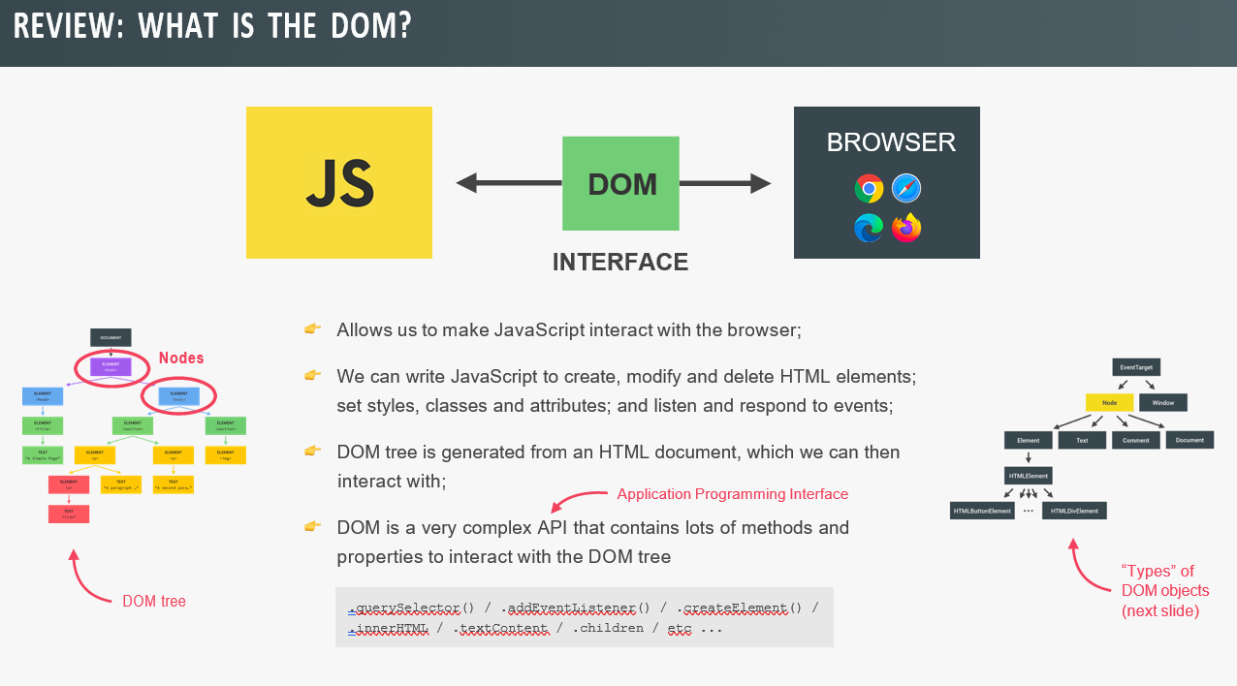

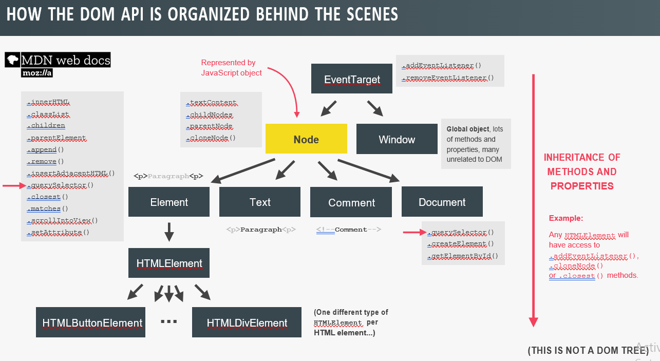

// **Selecting, Creating, and Deleting Elements**

// **Selecting elements**

console.log(document.documentElement);

console.log(document.head);

console.log(document.body);

const header = document.querySelector('.header');

const allSections = document.querySelectorAll('.section');

console.log(allSections);

document.getElementById('section--1');

const allButtons = document.getElementsByTagName('button');

console.log(allButtons);

console.log(document.getElementsByClassName('btn'));

// **Creating and inserting elements**

const message = document.createElement('div');

message.classList.add('cookie-message');

// message.textContent = 'We use cookied for improved functionality and analytics.';

message.innerHTML =

'We use cookied for improved functionality and analytics. <button class="btn btn--close-cookie">Got it!</button>';

// header.prepend(message);

header.append(message);

// header.append(message.cloneNode(true));

// header.before(message);

// header.after(message);

// Delete elements

document

.querySelector('.btn--close-cookie')

.addEventListener('click', function () {

// message.remove();

message.parentElement.removeChild(message);

});

///////////////////////////////////////

// **Styles, Attributes and Classes**

// **Styles**

message.style.backgroundColor = '#37383d';

message.style.width = '120%';

console.log(message.style.color);

console.log(message.style.backgroundColor);

console.log(getComputedStyle(message).color);

console.log(getComputedStyle(message).height);

message.style.height =

Number.parseFloat(getComputedStyle(message).height, 10) + 30 + 'px';

document.documentElement.style.setProperty('--color-primary', 'orangered');

// **Attributes**

const logo = document.querySelector('.nav__logo');

console.log(logo.alt);

console.log(logo.className);

logo.alt = 'Beautiful minimalist logo';

// **Non-standard**

console.log(logo.designer);

console.log(logo.getAttribute('designer'));

logo.setAttribute('company', 'Bankist');

console.log(logo.src);

console.log(logo.getAttribute('src'));

const link = document.querySelector('.nav__link--btn');

console.log(link.href);

console.log(link.getAttribute('href'));

// **Data attributes**

console.log(logo.dataset.versionNumber);

// Classes

logo.classList.add('c', 'j');

logo.classList.remove('c', 'j');

logo.classList.toggle('c');

logo.classList.contains('c'); // not includes

// Don't use

logo.clasName = 'jonas';

**Event Propagation: Bubbling and Capturing**

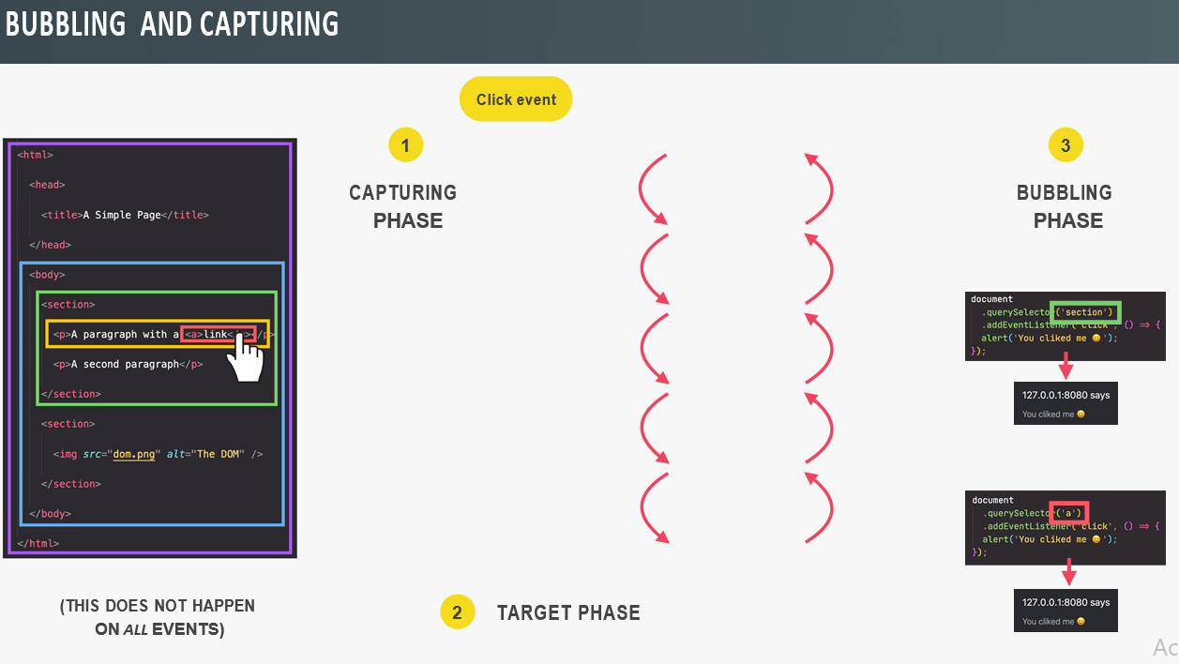

-JS Events has a important property, which capture and bubbling phase.

-this keyword and e.currenttarget are exactly gonna be same in any event handler

**DOM Traversing:** DOM Traversing is basically walking through the DOM, Which means we can select an element based on another element.

-Query Selector all it will go down as deep as it can for child element, but not for the indirect child element

**Guard Clause:** It is basically an if statement which will return early if some condition is matched.

if(!clicked) return;

**Bind:** Bind method creates a copy of the function that it’s called on and it will set this keyword in the function call, to whatever value we pass in the bind.

// **Types of Events and Event Handlers**

const h1 = document.querySelector('h1');

const alertH1 = function (e) {

alert('addEventListener: Great! You are reading the heading :D');

};

h1.addEventListener('mouseenter', alertH1);

setTimeout(() => h1.removeEventListener('mouseenter', alertH1), 3000);

// h1.onmouseenter = function (e) {

// alert('onmouseenter: Great! You are reading the heading :D');

// };

// **Event Propagation in Practice**

const randomInt = (min, max) =>

Math.floor(Math.random() * (max - min + 1) + min);

const randomColor = () =>

`rgb(${randomInt(0, 255)},${randomInt(0, 255)},${randomInt(0, 255)})`;

document.querySelector('.nav__link').addEventListener('click', function (e) {

this.style.backgroundColor = randomColor();

console.log('LINK', e.target, e.currentTarget);

console.log(e.currentTarget === this);

// Stop propagation

// e.stopPropagation();

});

document.querySelector('.nav__links').addEventListener('click', function (e) {

this.style.backgroundColor = randomColor();

console.log('CONTAINER', e.target, e.currentTarget);

});

document.querySelector('.nav').addEventListener('click', function (e) {

this.style.backgroundColor = randomColor();

console.log('NAV', e.target, e.currentTarget);

});

// **DOM Traversing**

const h1 = document.querySelector('h1');

// Going downwards: child

console.log(h1.querySelectorAll('.highlight'));

console.log(h1.childNodes);

console.log(h1.children);

h1.firstElementChild.style.color = 'white';

h1.lastElementChild.style.color = 'orangered';

// Going upwards: parents

console.log(h1.parentNode);

console.log(h1.parentElement);

h1.closest('.header').style.background = 'var(--gradient-secondary)';

h1.closest('h1').style.background = 'var(--gradient-primary)';

// Going sideways: siblings

console.log(h1.previousElementSibling);

console.log(h1.nextElementSibling);

console.log(h1.previousSibling);

console.log(h1.nextSibling);

console.log(h1.parentElement.children);

[...h1.parentElement.children].forEach(function (el) {

if (el !== h1) el.style.transform = 'scale(0.5)';

});

// **Sticky navigation**

const initialCoords = section1.getBoundingClientRect();

console.log(initialCoords);

window.addEventListener('scroll', function () {

console.log(window.scrollY);

if (window.scrollY > initialCoords.top) nav.classList.add('sticky');

else nav.classList.remove('sticky');

});

// **Lifecycle DOM Events**

document.addEventListener('DOMContentLoaded', function (e) {

console.log('HTML parsed and DOM tree built!', e);

});

window.addEventListener('load', function (e) {

console.log('Page fully loaded', e);

});

window.addEventListener('beforeunload', function (e) {

e.preventDefault();

console.log(e);

e.returnValue = '';

});

**Async & Defer in JS:**

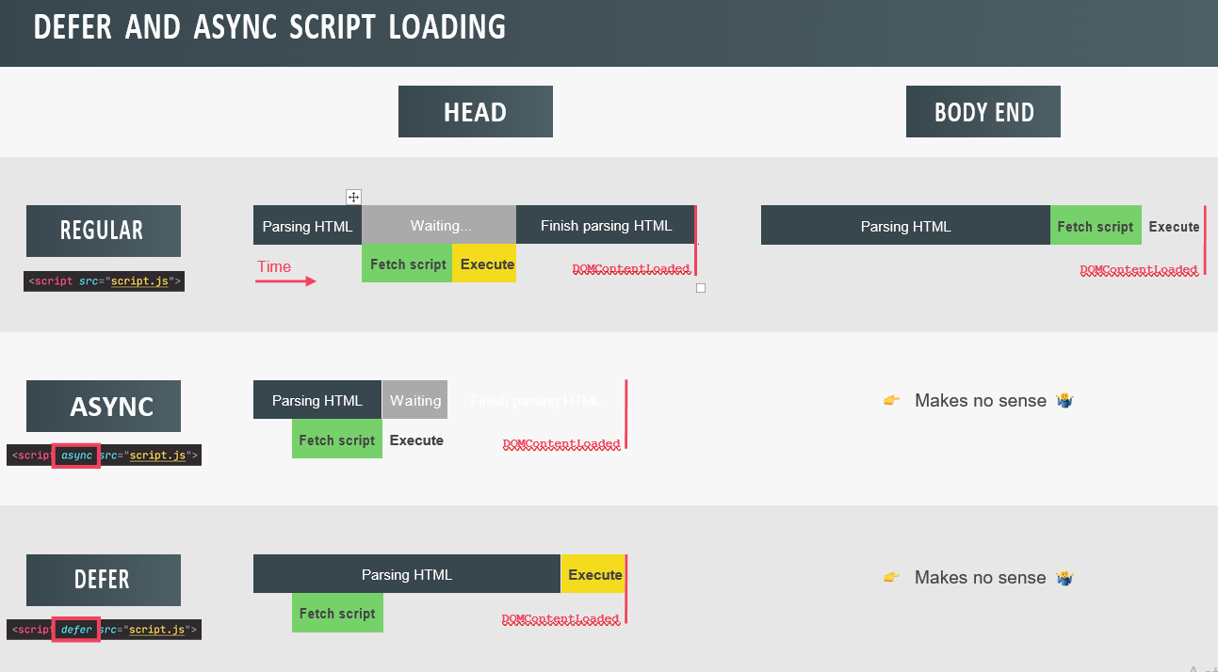

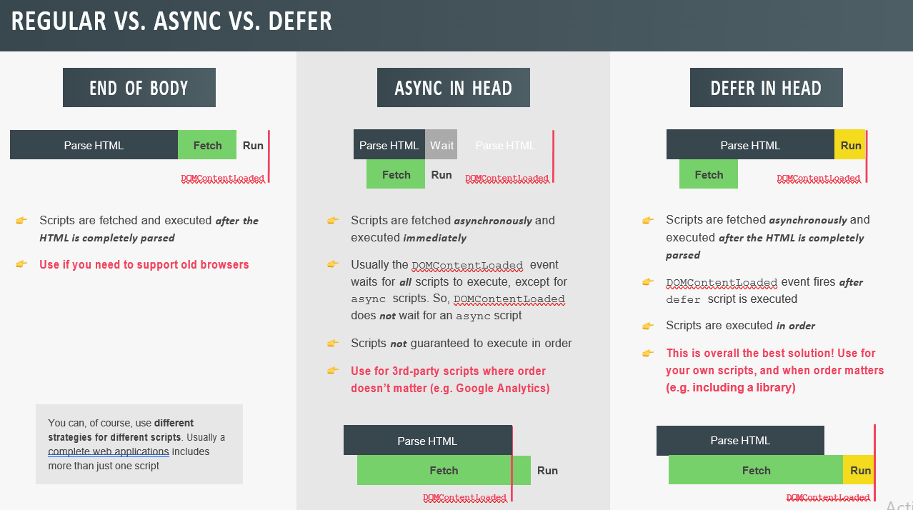

Async and differ are Boolean attribute, that are used with along with script tag to load the external script efficiently into our web page.

**OOPS:**

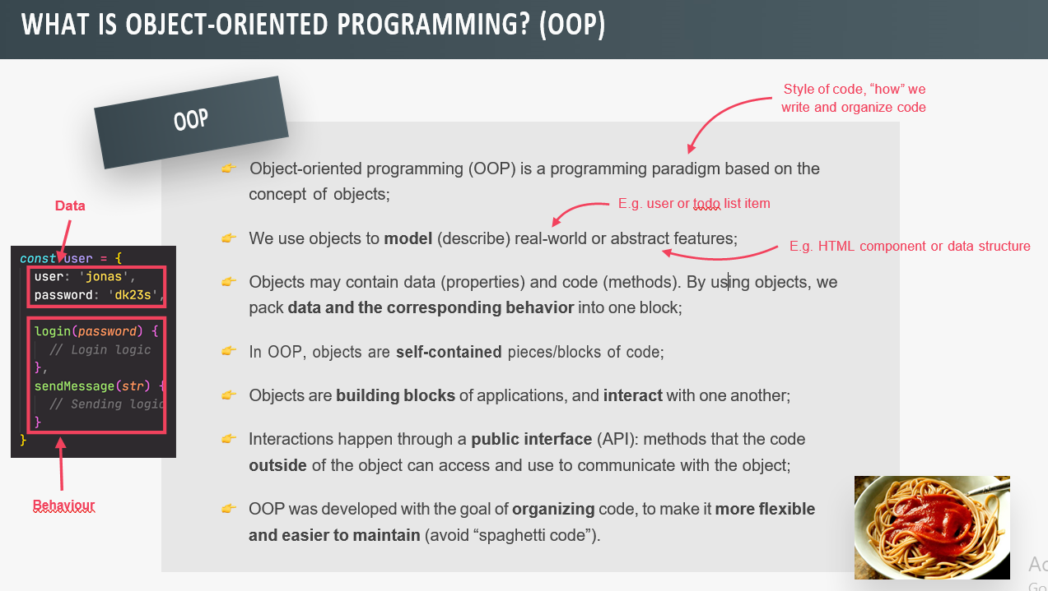

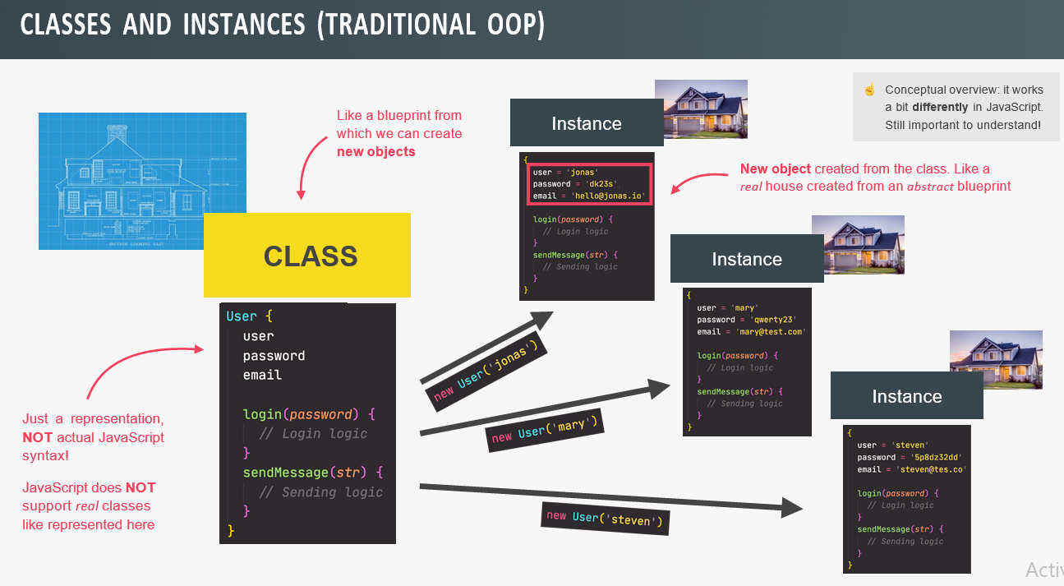

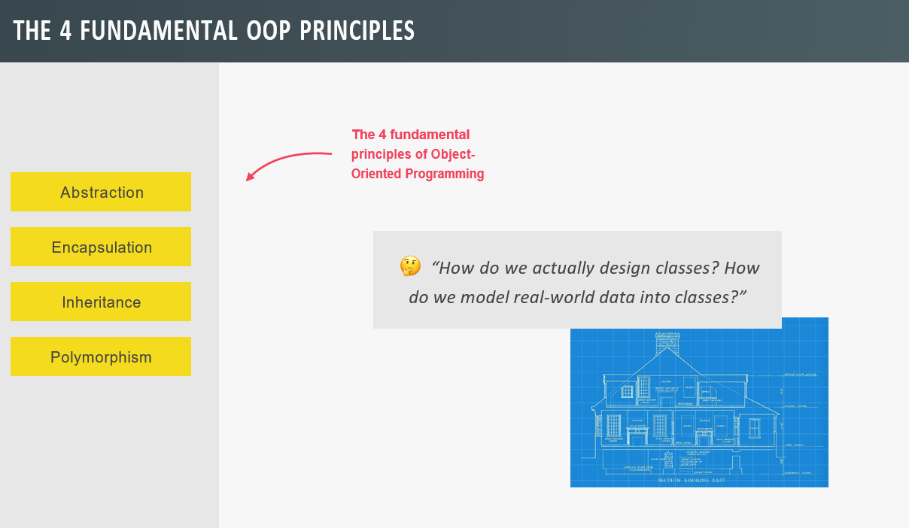

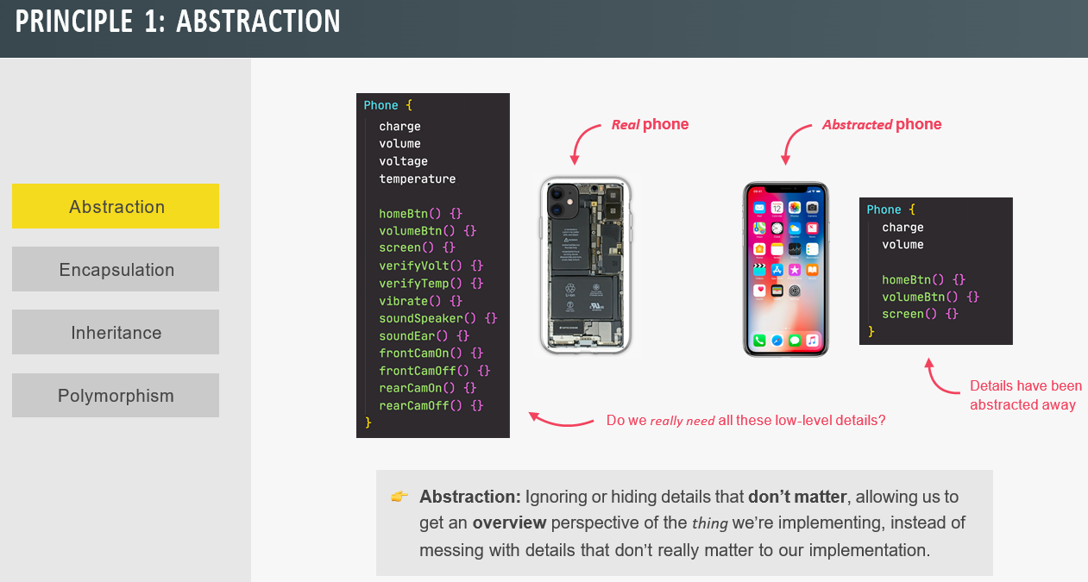

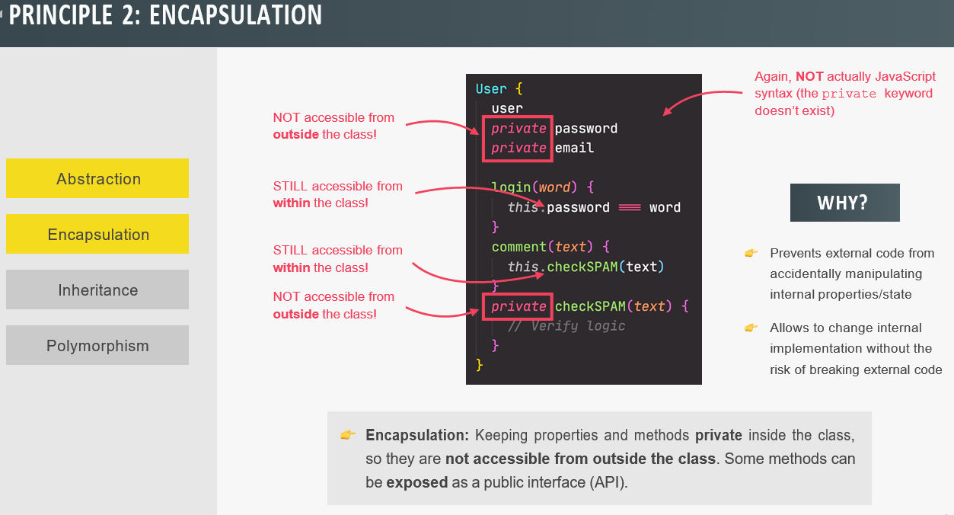

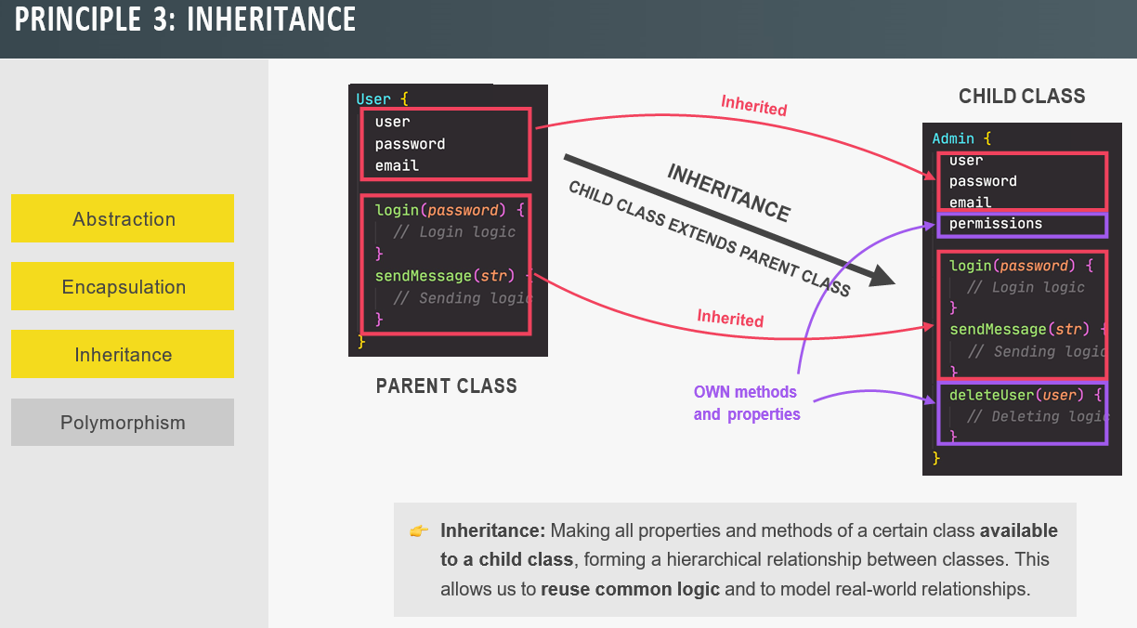

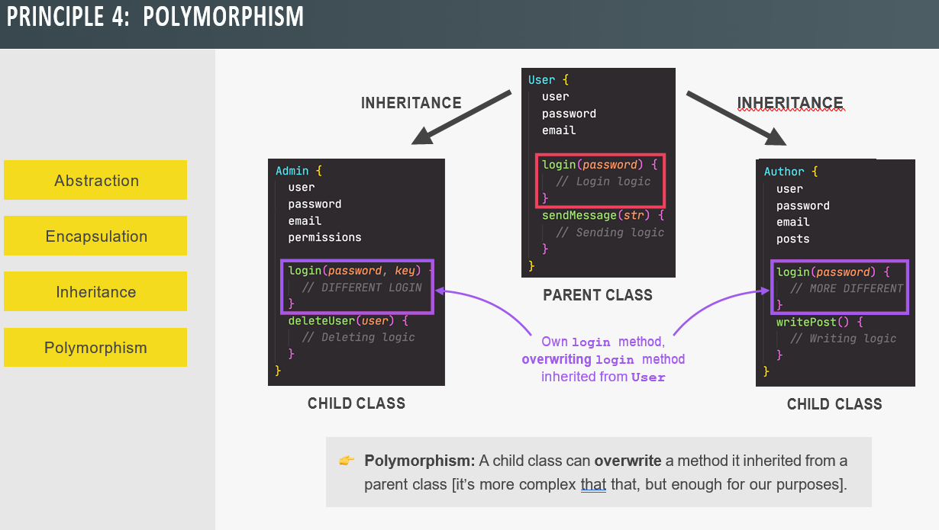

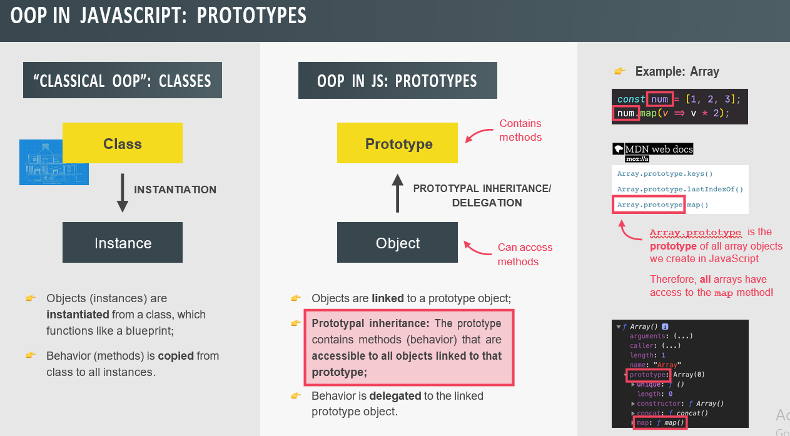

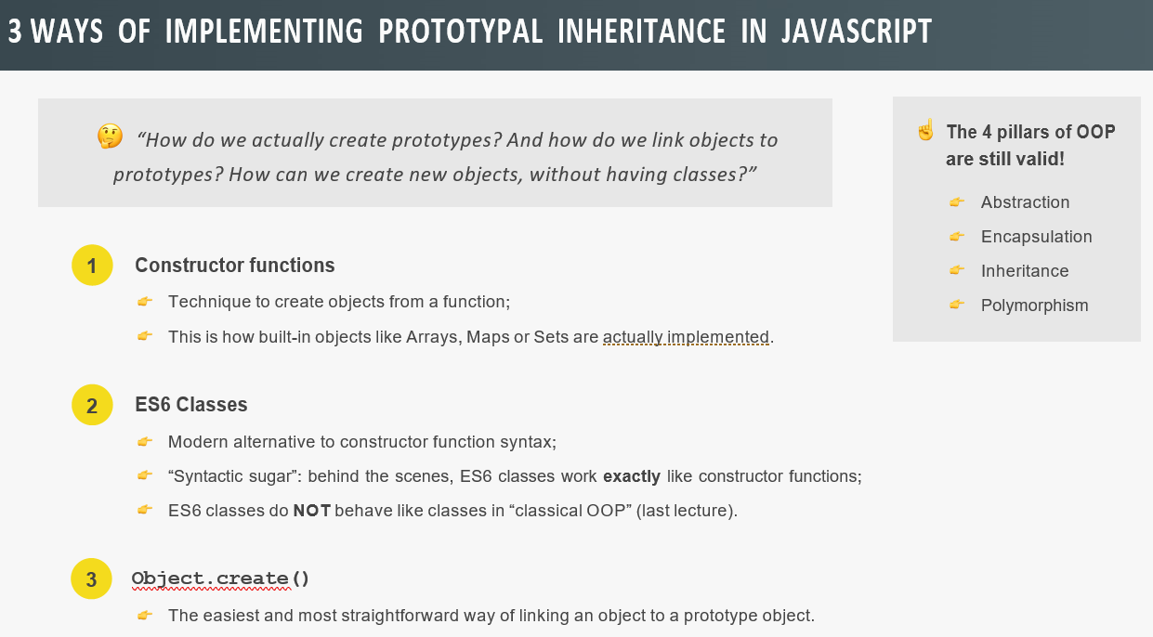

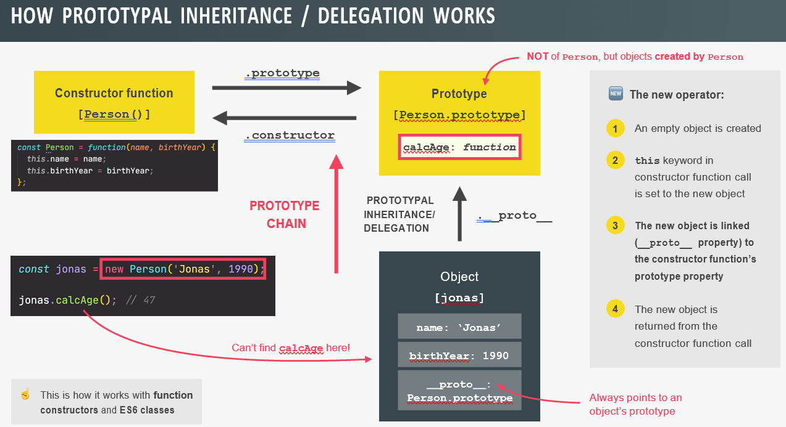

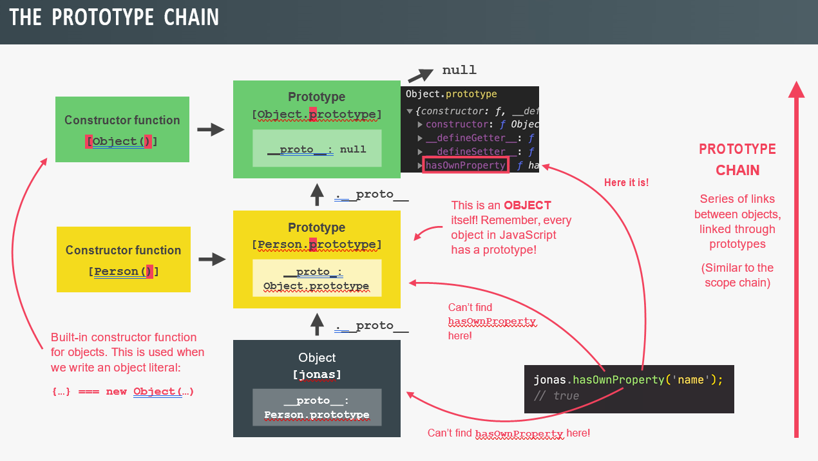

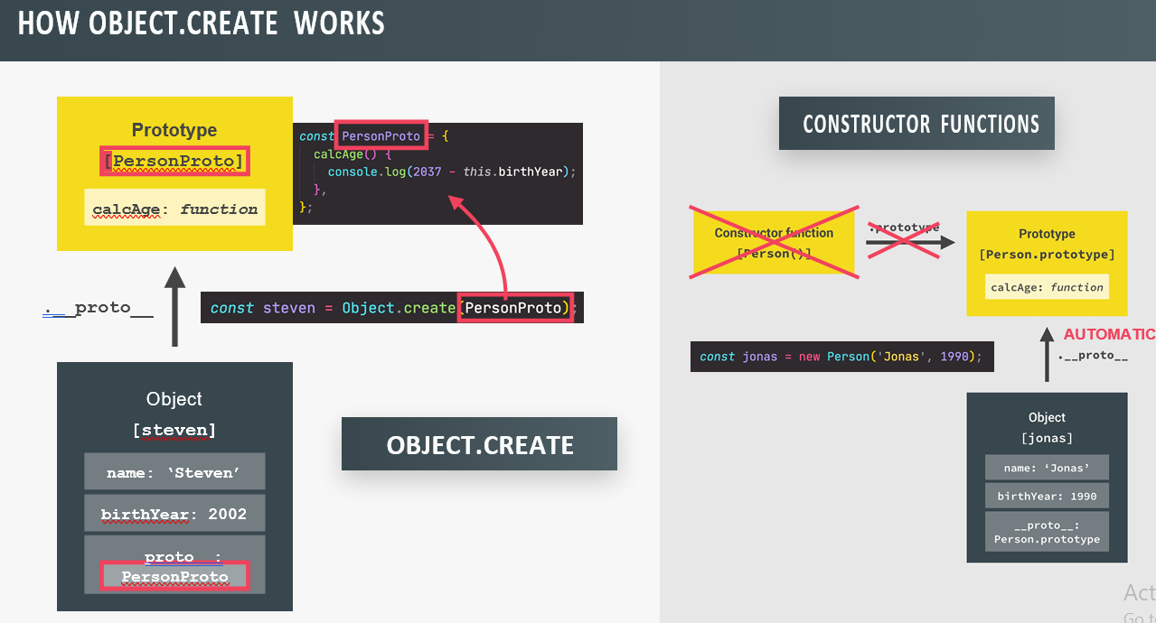

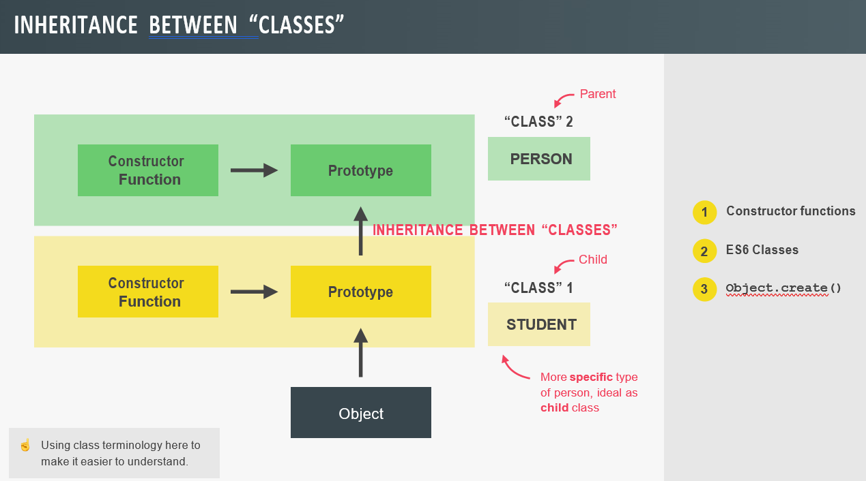

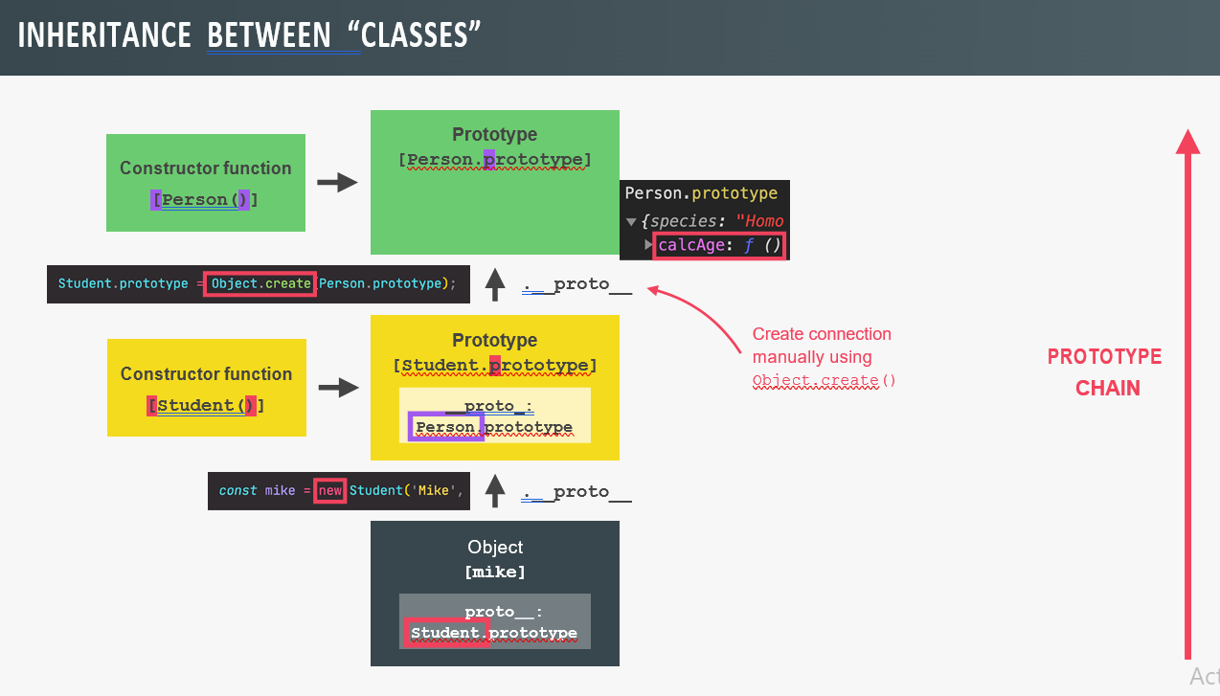

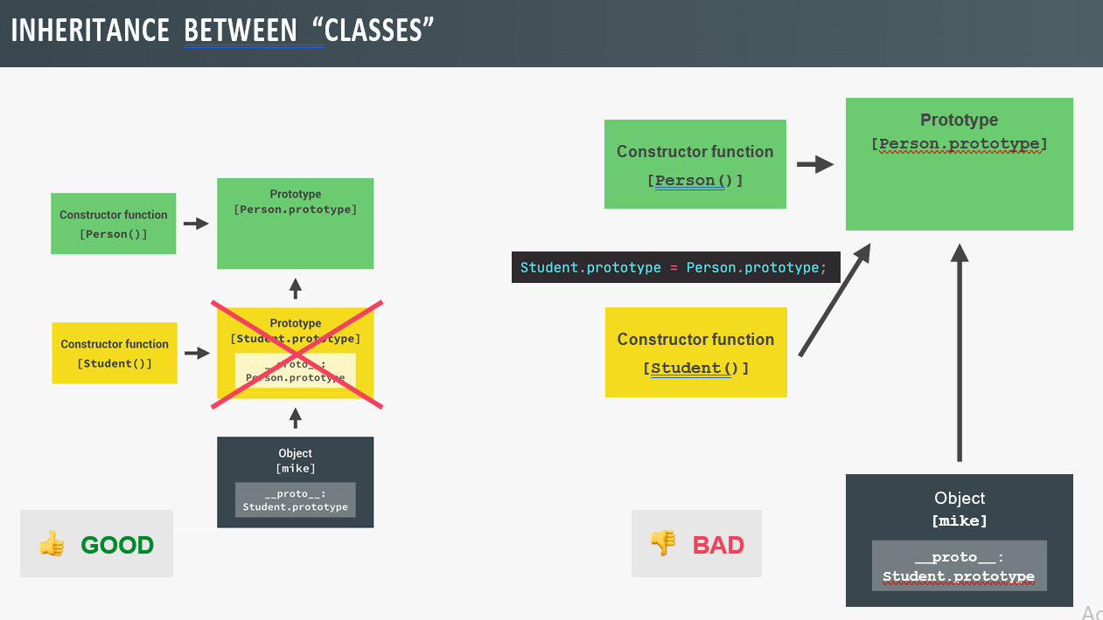

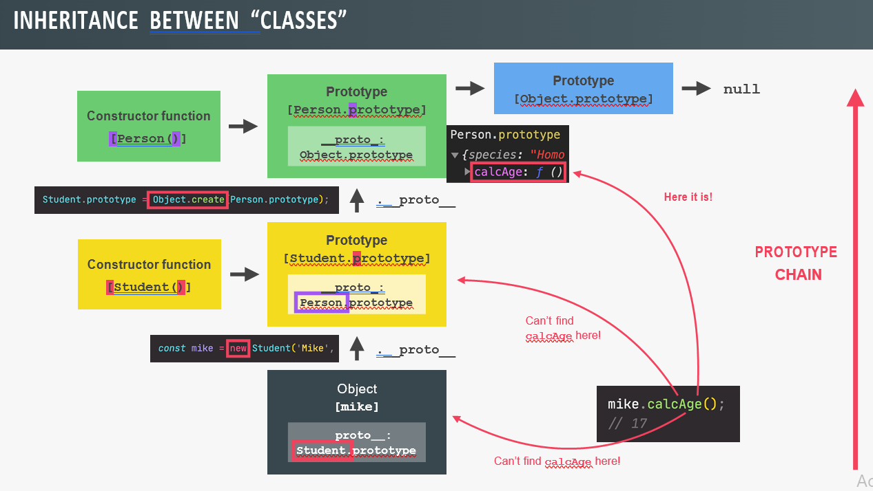

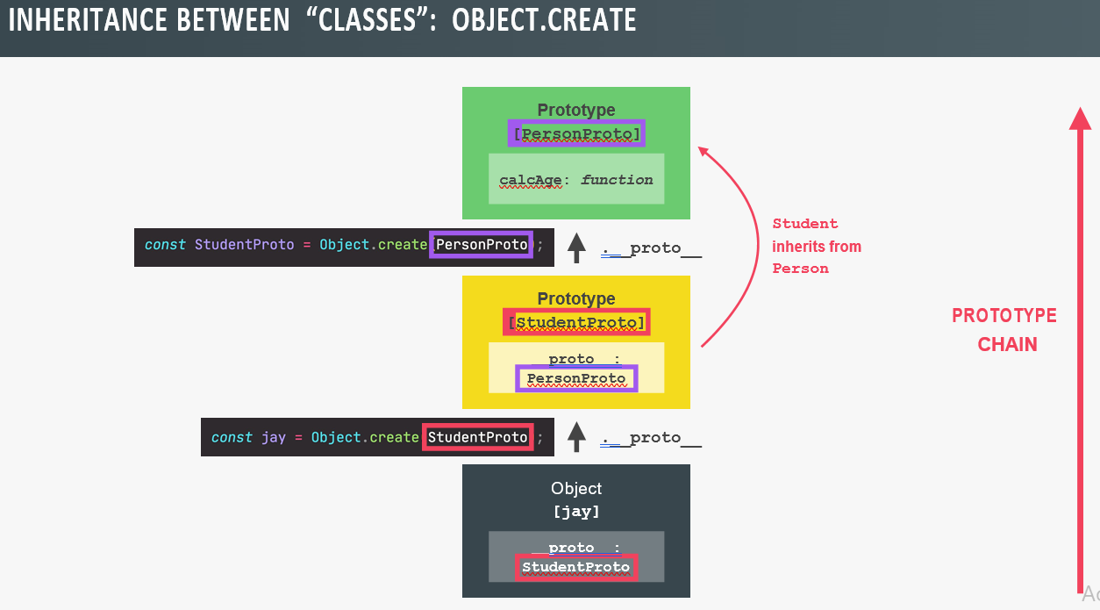

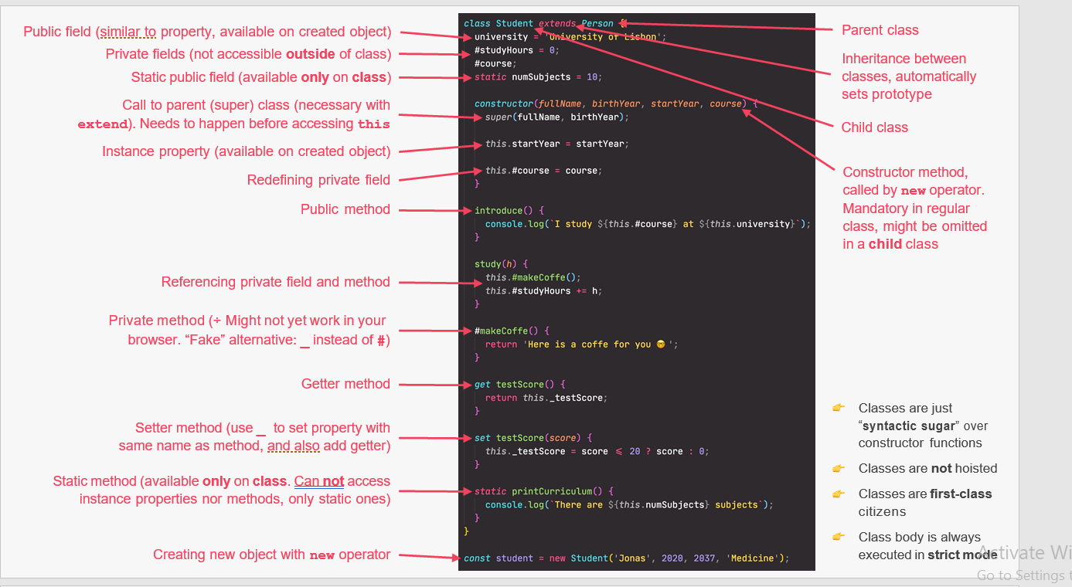

// **Constructor Functions and the new Operator**

const Person = function (firstName, birthYear) {

// Instance properties

this.firstName = firstName;

this.birthYear = birthYear;

// Never to this!

// this.calcAge = function () {

// console.log(2037 - this.birthYear);

// };

};

const jonas = new Person('Jonas', 1991);

console.log(jonas);

**// 1. New {} is created**

**// 2. function is called, this = {}**

**// 3. {} linked to prototype**

**// 4. function automatically return {}**

const matilda = new Person('Matilda', 2017);

const jack = new Person('Jack', 1975);

console.log(jonas instanceof Person);

Person.hey = function () {

console.log('Hey there 👋');

console.log(this);

};

Person.hey();

// **Prototypes**

console.log(Person.prototype);

Person.prototype.calcAge = function () {

console.log(2037 - this.birthYear);

};

jonas.calcAge();

matilda.calcAge();

console.log(jonas.__proto__);

console.log(jonas.__proto__ === Person.prototype);

console.log(Person.prototype.isPrototypeOf(jonas));

console.log(Person.prototype.isPrototypeOf(matilda));

console.log(Person.prototype.isPrototypeOf(Person));

// **.prototyeOfLinkedObjects**

Person.prototype.species = 'Homo Sapiens';

console.log(jonas.species, matilda.species);

console.log(jonas.hasOwnProperty('firstName'));

console.log(jonas.hasOwnProperty('species'));

// **Prototypal Inheritance on Built-In Objects**

console.log(jonas.__proto__);

// Object.prototype (top of prototype chain)

console.log(jonas.__proto__.__proto__);

console.log(jonas.__proto__.__proto__.__proto__);

console.dir(Person.prototype.constructor);

const arr = [3, 6, 6, 5, 6, 9, 9]; // new Array === []

console.log(arr.__proto__);

console.log(arr.__proto__ === Array.prototype);

console.log(arr.__proto__.__proto__);

Array.prototype.unique = function () {

return [...new Set(this)];

};

console.log(arr.unique());

const h1 = document.querySelector('h1');

console.dir(x => x + 1);

**// ES6 Classes**

**// Class expression**

// const PersonCl = class {}

// Class declaration

class PersonCl {

constructor(fullName, birthYear) {

this.fullName = fullName;

this.birthYear = birthYear;

}

// Instance methods

// Methods will be added to .prototype property

calcAge() {

console.log(2037 - this.birthYear);

}

greet() {

console.log(`Hey ${this.fullName}`);

}

get age() {

return 2037 - this.birthYear;

}

// **Set a property that already exists**

set fullName(name) {

if (name.includes(' ')) this._fullName = name;

else alert(`${name} is not a full name!`);

}

get fullName() {

return this._fullName;

}

// **Static method**

static hey() {

console.log('Hey there 👋');

console.log(this);

}

}

const jessica = new PersonCl('Jessica Davis', 1996);

console.log(jessica);

jessica.calcAge();

console.log(jessica.age);

console.log(jessica.__proto__ === PersonCl.prototype);

// PersonCl.prototype.greet = function () {

// console.log(`Hey ${this.firstName}`);

// };

jessica.greet();

// **1. Classes are NOT hoisted**

**// 2. Classes are first-class citizens**

**// 3. Classes are executed in strict mode**

const walter = new PersonCl('Walter White', 1965);

// PersonCl.hey();

// **Setters and Getters**

const account = {

owner: 'Jonas',

movements: [200, 530, 120, 300],

get latest() {

return this.movements.slice(-1).pop();

},

set latest(mov) {

this.movements.push(mov);

},

};

console.log(account.latest);

account.latest = 50;

console.log(account.movements);

// **Object.create**

const PersonProto = {

calcAge() {

console.log(2037 - this.birthYear);

},

init(firstName, birthYear) {

this.firstName = firstName;

this.birthYear = birthYear;

},

};

const steven = Object.create(PersonProto);

console.log(steven);

steven.name = 'Steven';

steven.birthYear = 2002;

steven.calcAge();

console.log(steven.__proto__ === PersonProto);

const sarah = Object.create(PersonProto);

sarah.init('Sarah', 1979);

sarah.calcAge();

// **Inheritance Between "Classes": Constructor Functions**

const Person = function (firstName, birthYear) {

this.firstName = firstName;

this.birthYear = birthYear;

};

Person.prototype.calcAge = function () {

console.log(2037 - this.birthYear);

};

const Student = function (firstName, birthYear, course) {

Person.call(this, firstName, birthYear);

this.course = course;

};

// **Linking prototypes**

Student.prototype = Object.create(Person.prototype);

Student.prototype.introduce = function () {

console.log(`My name is ${this.firstName} and I study ${this.course}`);

};

const mike = new Student('Mike', 2020, 'Computer Science');

mike.introduce();

mike.calcAge();

console.log(mike.__proto__);

console.log(mike.__proto__.__proto__);

console.log(mike instanceof Student);

console.log(mike instanceof Person);

console.log(mike instanceof Object);

Student.prototype.constructor = Student;

console.dir(Student.prototype.constructor);

**// Inheritance Between "Classes": ES6 Classes**

class PersonCl {

constructor(fullName, birthYear) {

this.fullName = fullName;

this.birthYear = birthYear;

}

// Instance methods

calcAge() {

console.log(2037 - this.birthYear);

}

greet() {

console.log(`Hey ${this.fullName}`);

}

get age() {

return 2037 - this.birthYear;

}

set fullName(name) {

if (name.includes(' ')) this._fullName = name;

else alert(`${name} is not a full name!`);

}

get fullName() {

return this._fullName;

}

// Static method

static hey() {

console.log('Hey there 👋');

}

}

class StudentCl extends PersonCl {

constructor(fullName, birthYear, course) {

// Always needs to happen first!

super(fullName, birthYear);

this.course = course;

}

introduce() {

console.log(`My name is ${this.fullName} and I study ${this.course}`);

}

calcAge() {

console.log(

`I'm ${

2037 - this.birthYear

} years old, but as a student I feel more like ${

2037 - this.birthYear + 10

}`

);

}

}

const martha = new StudentCl('Martha Jones', 2012, 'Computer Science');

martha.introduce();

martha.calcAge();

**// Inheritance Between "Classes": Object.create**

const PersonProto = {

calcAge() {

console.log(2037 - this.birthYear);

},

init(firstName, birthYear) {

this.firstName = firstName;

this.birthYear = birthYear;

},

};

const steven = Object.create(PersonProto);

const StudentProto = Object.create(PersonProto);

StudentProto.init = function (firstName, birthYear, course) {

PersonProto.init.call(this, firstName, birthYear);

this.course = course;

};

StudentProto.introduce = function () {

// BUG in video:

// console.log(`My name is ${this.fullName} and I study ${this.course}`);

// FIX:

console.log(`My name is ${this.firstName} and I study ${this.course}`);

};

const jay = Object.create(StudentProto);

jay.init('Jay', 2010, 'Computer Science');

jay.introduce();

jay.calcAge();

**// Encapsulation: Protected Properties and Methods**

**// Encapsulation: Private Class Fields and Methods**

// 1) Public fields

// 2) Private fields

// 3) Public methods

// 4) Private methods

// (there is also the static version)

class Account {

// 1) Public fields (instances)

locale = navigator.language;

// 2) Private fields (instances)

#movements = [];

#pin;

constructor(owner, currency, pin) {

this.owner = owner;

this.currency = currency;

this.#pin = pin;

// Protected property

// this._movements = [];

// this.locale = navigator.language;

console.log(`Thanks for opening an account, ${owner}`);

}

// 3) Public methods

// Public interface

getMovements() {

return this.#movements;

}

deposit(val) {

this.#movements.push(val);

return this;

}

withdraw(val) {

this.deposit(-val);

return this;

}

requestLoan(val) {

// if (this.#approveLoan(val)) {

if (this._approveLoan(val)) {

this.deposit(val);

console.log(`Loan approved`);

return this;

}

}

static helper() {

console.log('Helper');

}

// 4) Private methods

// #approveLoan(val) {

_approveLoan(val) {

return true;

}

}

const acc1 = new Account('Jonas', 'EUR', 1111);

// acc1._movements.push(250);

// acc1._movements.push(-140);

// acc1.approveLoan(1000);

acc1.deposit(250);

acc1.withdraw(140);

acc1.requestLoan(1000);

console.log(acc1.getMovements());

console.log(acc1);

Account.helper();

// console.log(acc1.#movements);

// console.log(acc1.#pin);

// console.log(acc1.#approveLoan(100));

// Chaining

acc1.deposit(300).deposit(500).withdraw(35).requestLoan(25000).withdraw(4000);

console.log(acc1.getMovements());

**Local Storage:**

_setLocalStorage() {

localStorage.setItem('workouts', JSON.stringify(this.#workouts));

}

_getLocalStorage() {

const data = JSON.parse(localStorage.getItem('workouts'));

if (!data) return;

this.#workouts = data;

this.#workouts.forEach(work => {

this._renderWorkout(work);

});

}

reset() {

localStorage.removeItem('workouts');

location.reload();

}

}

**Asynchronous JS:**

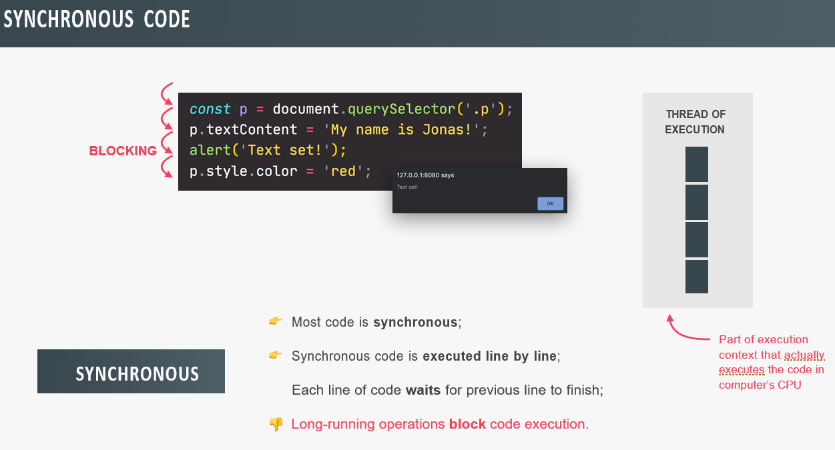

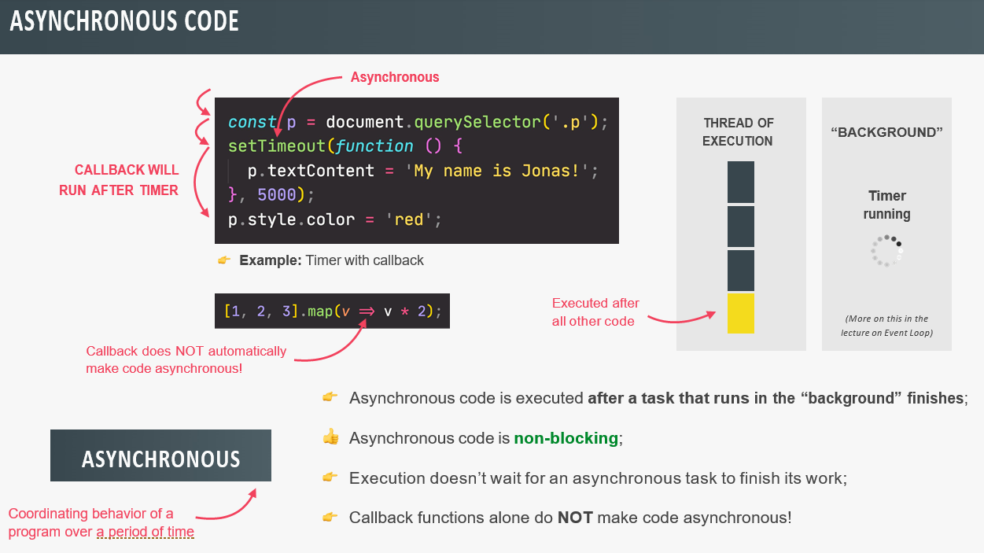

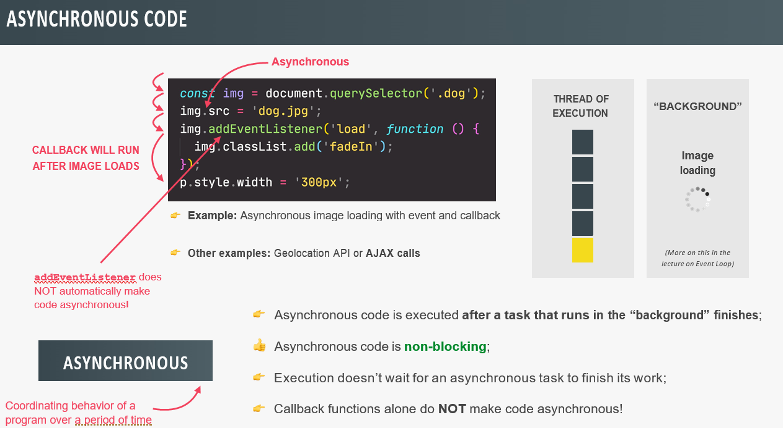

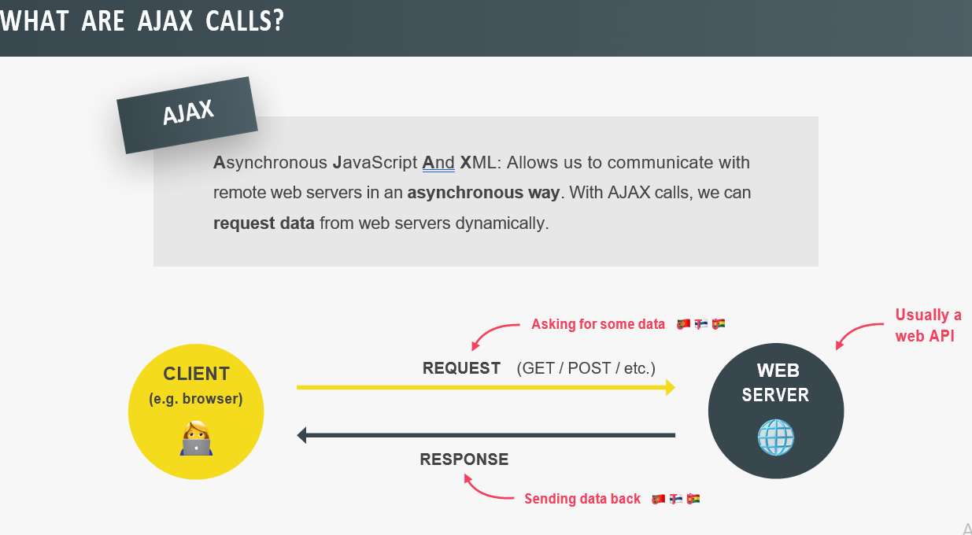

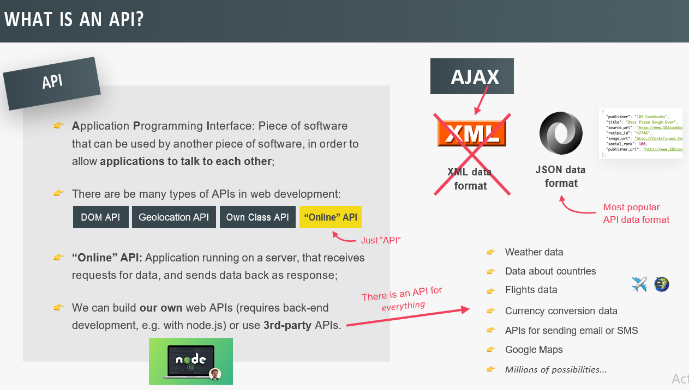

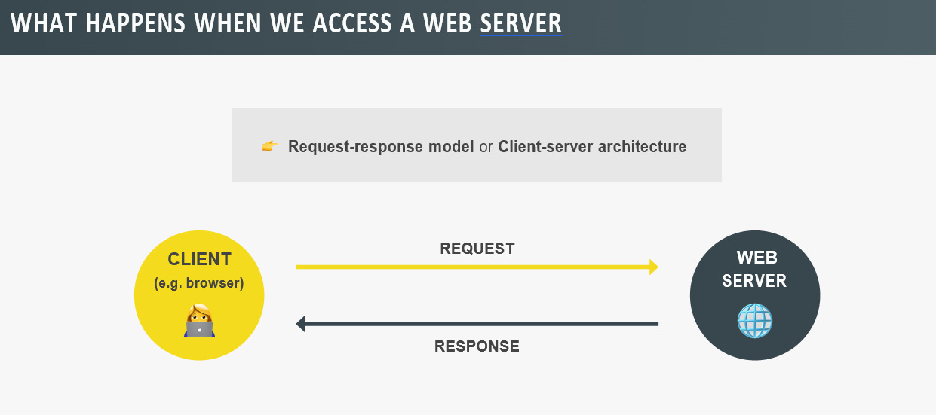

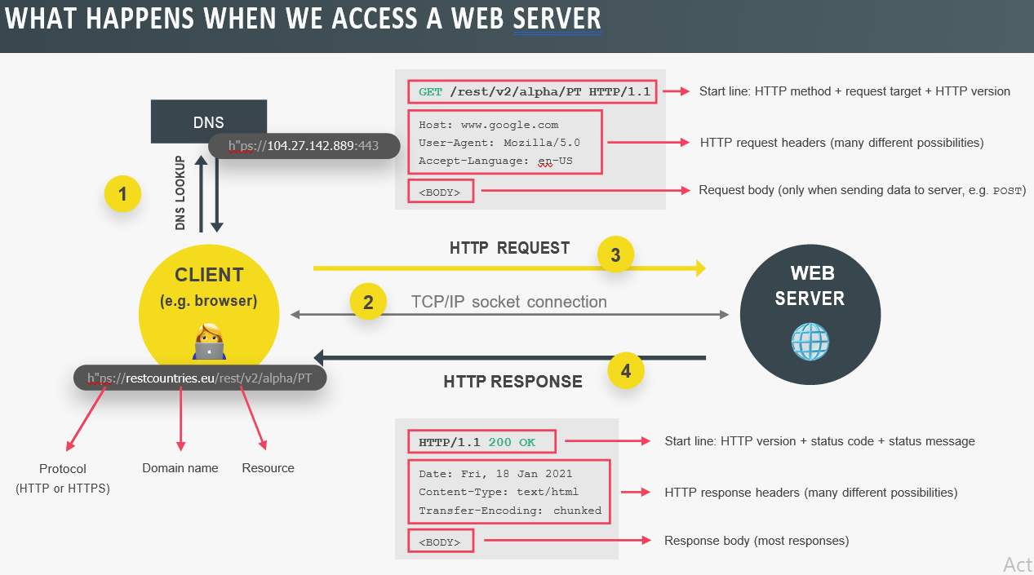

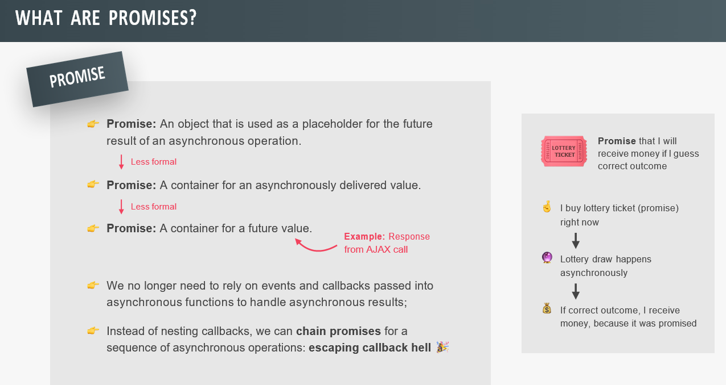

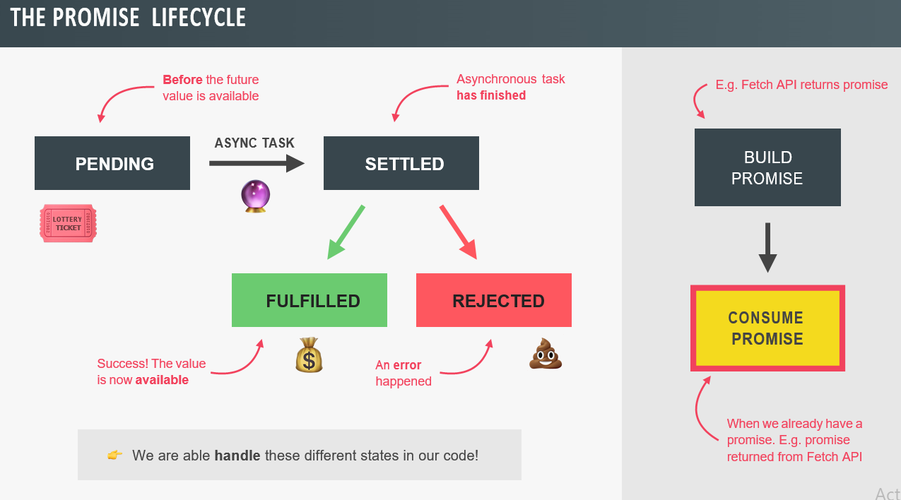

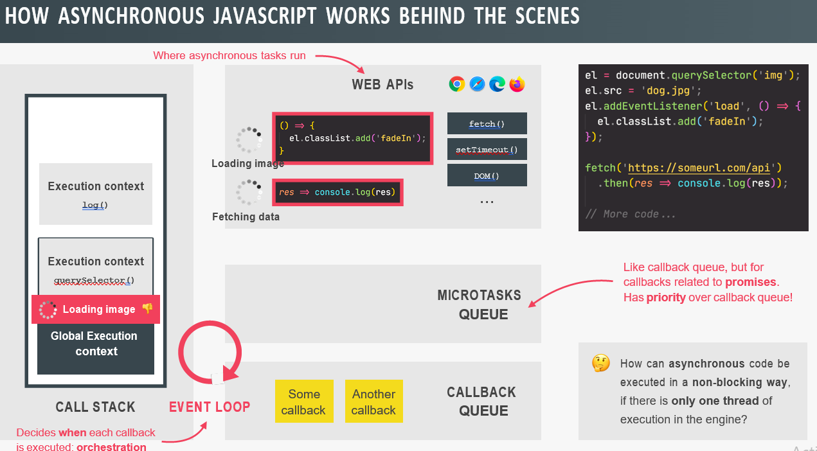

**Promisifying:** Promisifying means to convert callback based asynchronous behavior to promise based.

**Async & Await:**

Const whereAmI = async function(){

//consume promise(can have one or more await)

}

-This function is now an asynchronous function. So, a function that will basically keep running in the background while performing the code that is inside of it, then when this function is done it automatically returns a promise.

-In an async function we can use the await keyword to basically await for the result of the promise.

-So, basically await will stop code execution at this point of the function until the promise is fulfilled and so until the data is been fetched.

// **Our First AJAX Call: XMLHttpRequest**

const getCountryData = function (country) {

const request = new XMLHttpRequest();

request.open('GET', `https://restcountries.eu/rest/v2/name/${country}`);

request.send();

request.addEventListener('load', function () {

const [data] = JSON.parse(this.responseText);

console.log(data);

const html = `

<article class="country">

<img class="country__img" src="${data.flag}" />

<div class="country__data">

<h3 class="country__name">${data.name}</h3>

<h4 class="country__region">${data.region}</h4>

<p class="country__row"><span>👫</span>${(

+data.population / 1000000

).toFixed(1)} people</p>

<p class="country__row"><span>🗣️</span>${data.languages[0].name}</p>

<p class="country__row"><span>💰</span>${data.currencies[0].name}</p>

</div>

</article>

`;

countriesContainer.insertAdjacentHTML('beforeend', html);

countriesContainer.style.opacity = 1;

});

};

getCountryData('portugal');

getCountryData('usa');

getCountryData('germany');

// **Welcome to Callback Hell**

/*

const getCountryAndNeighbour = function (country) {

// AJAX call country 1

const request = new XMLHttpRequest();

request.open('GET', `https://restcountries.eu/rest/v2/name/${country}`);

request.send();

request.addEventListener('load', function () {

const [data] = JSON.parse(this.responseText);

console.log(data);

// Render country 1

renderCountry(data);

// Get neighbour country (2)

const [neighbour] = data.borders;

if (!neighbour) return;

// AJAX call country 2

const request2 = new XMLHttpRequest();

request2.open('GET', `https://restcountries.eu/rest/v2/alpha/${neighbour}`);

request2.send();

request2.addEventListener('load', function () {

const data2 = JSON.parse(this.responseText);

console.log(data2);

renderCountry(data2, 'neighbour');

});

});

};

// getCountryAndNeighbour('portugal');

getCountryAndNeighbour('usa');

**// Consuming Promises**

**// Chaining Promises**

**// Handling Rejected Promises**

**// Throwing Errors Manually**

// const getCountryData = function (country) {

// fetch(`https://restcountries.eu/rest/v2/name/${country}`)

// .then(function (response) {

// console.log(response);

// return response.json();

// })

// .then(function (data) {

// console.log(data);

// renderCountry(data[0]);

// });

// };

// const getCountryData = function (country) {

// // Country 1

// fetch(`https://restcountries.eu/rest/v2/name/${country}`)

// .then(response => {

// console.log(response);

// if (!response.ok)

// throw new Error(`Country not found (${response.status})`);

// return response.json();

// })

// .then(data => {

// renderCountry(data[0]);

// // const neighbour = data[0].borders[0];

// const neighbour = 'dfsdfdef';

// if (!neighbour) return;

// // Country 2

// return fetch(`https://restcountries.eu/rest/v2/alpha/${neighbour}`);

// })

// .then(response => {

// if (!response.ok)

// throw new Error(`Country not found (${response.status})`);

// return response.json();

// })

// .then(data => renderCountry(data, 'neighbour'))

// .catch(err => {

// console.error(`${err} 💥💥💥`);

// renderError(`Something went wrong 💥💥 ${err.message}. Try again!`);

// })

// .finally(() => {

// countriesContainer.style.opacity = 1;

// });

// };

const getCountryData = function (country) {

// Country 1

getJSON(

`https://restcountries.eu/rest/v2/name/${country}`,

'Country not found'

)

.then(data => {

renderCountry(data[0]);

const neighbour = data[0].borders[0];

if (!neighbour) throw new Error('No neighbour found!');

// Country 2

return getJSON(

`https://restcountries.eu/rest/v2/alpha/${neighbour}`,

'Country not found'

);

})

.then(data => renderCountry(data, 'neighbour'))

.catch(err => {

console.error(`${err} 💥💥💥`);

renderError(`Something went wrong 💥💥 ${err.message}. Try again!`);

})

.finally(() => {

countriesContainer.style.opacity = 1;

});

};

btn.addEventListener('click', function () {

getCountryData('portugal');

});

// getCountryData('australia');

*/

// **Promisifying the Geolocation API**

const getPosition = function () {

return new Promise(function (resolve, reject) {

// navigator.geolocation.getCurrentPosition(

// position => resolve(position),

// err => reject(err)

// );

navigator.geolocation.getCurrentPosition(resolve, reject);

});

};

// getPosition().then(pos => console.log(pos));

const whereAmI = function () {

getPosition()

.then(pos => {

const { latitude: lat, longitude: lng } = pos.coords;

return fetch(`https://geocode.xyz/${lat},${lng}?geoit=json`);

})

.then(res => {

if (!res.ok) throw new Error(`Problem with geocoding ${res.status}`);

return res.json();

})

.then(data => {

console.log(data);

console.log(`You are in ${data.city}, ${data.country}`);

return fetch(`https://restcountries.eu/rest/v2/name/${data.country}`);

})

.then(res => {

if (!res.ok) throw new Error(`Country not found (${res.status})`);

return res.json();

})

.then(data => renderCountry(data[0]))

.catch(err => console.error(`${err.message} 💥`));

};

btn.addEventListener('click', whereAmI);

**// Consuming Promises with Async/Await**

**// Error Handling With try...catch**

const getPosition = function () {

return new Promise(function (resolve, reject) {

navigator.geolocation.getCurrentPosition(resolve, reject);

});

};

// fetch(`https://restcountries.eu/rest/v2/name/${country}`).then(res => console.log(res))

const whereAmI = async function () {

try {

// Geolocation

const pos = await getPosition();

const { latitude: lat, longitude: lng } = pos.coords;

// Reverse geocoding

const resGeo = await fetch(`https://geocode.xyz/${lat},${lng}?geoit=json`);

if (!resGeo.ok) throw new Error('Problem getting location data');

const dataGeo = await resGeo.json();

console.log(dataGeo);

// Country data

const res = await fetch(

`https://restcountries.eu/rest/v2/name/${dataGeo.country}`

);

// BUG in video:

// if (!resGeo.ok) throw new Error('Problem getting country');

// FIX:

if (!res.ok) throw new Error('Problem getting country');

const data = await res.json();

console.log(data);

renderCountry(data[0]);

} catch (err) {

console.error(`${err} 💥`);

renderError(`💥 ${err.message}`);

}

};

whereAmI();

// **Running Promises in Parallel**

const get3Countries = async function (c1, c2, c3) {

try {

// const [data1] = await getJSON(

// `https://restcountries.eu/rest/v2/name/${c1}`

// );

// const [data2] = await getJSON(

// `https://restcountries.eu/rest/v2/name/${c2}`

// );

// const [data3] = await getJSON(

// `https://restcountries.eu/rest/v2/name/${c3}`

// );

// console.log([data1.capital, data2.capital, data3.capital]);

const data = await Promise.all([

getJSON(`https://restcountries.eu/rest/v2/name/${c1}`),

getJSON(`https://restcountries.eu/rest/v2/name/${c2}`),

getJSON(`https://restcountries.eu/rest/v2/name/${c3}`),

]);

console.log(data.map(d => d[0].capital));

} catch (err) {

console.error(err);

}

};

get3Countries('portugal', 'canada', 'tanzania');

**// Other Promise Combinators: race, allSettled and any**

**// Promise.race**

(async function () {

const res = await Promise.race([

getJSON(`https://restcountries.eu/rest/v2/name/italy`),

getJSON(`https://restcountries.eu/rest/v2/name/egypt`),

getJSON(`https://restcountries.eu/rest/v2/name/mexico`),

]);

console.log(res[0]);

})();

const timeout = function (sec) {

return new Promise(function (_, reject) {

setTimeout(function () {

reject(new Error('Request took too long!'));

}, sec * 1000);

});

};

Promise.race([

getJSON(`https://restcountries.eu/rest/v2/name/tanzania`),

timeout(5),

])

.then(res => console.log(res[0]))

.catch(err => console.error(err));

// **Promise.allSettled**

Promise.allSettled([

Promise.resolve('Success'),

Promise.reject('ERROR'),

Promise.resolve('Another success'),

]).then(res => console.log(res));

Promise.all([

Promise.resolve('Success'),

Promise.reject('ERROR'),

Promise.resolve('Another success'),

])

.then(res => console.log(res))

.catch(err => console.error(err));

// **Promise.any [ES2021]**

Promise.any([

Promise.resolve('Success'),

Promise.reject('ERROR'),

Promise.resolve('Another success'),

])

.then(res => console.log(res))

.catch(err => console.error(err));

**Akshay Saini Tutorials**

**Call, Apply and Bind:**

Using Call method we can do function borrowing. i.e. borrowing function from another object and using it without writing it again in another object.

-In call method the first parameter will be reference and rest of them is arguments you wants to pass in method.

-The only difference between call and apply method is the way we pass argument. In Call method we take comma separated value and in Apply method we take array of arguments.

-The bind method looks exactly the same as call method but the only difference is instead of calling the method here, the bind method bind this method ‘printFullName()’ with the object and return as the copy of that method and it will bind to name2 object and will return a function

-The catch is it doesn’t call the method directly like in call method, but instead it will make an function and that can be called later.

-This bind method basically used to bind and keep the copy of the method for later use.

//call, apply, bind

// let name = {

//     firstName: "summy",

//     lastName: "singh",

//     printFullName: function(){

//         console.log(`${this.firstName} ${this.lastName}`);

//     }

// }

// name.printFullName();

// let name2 = {

//     firstName:"Leo",

//     lastName:"Messi"

// }

// //function borrowing

// name.printFullName.call(name2);

let name = {

    firstName: "summy",

    lastName: "singh",

}

//in general case:

let printFullName = function(hometown, state){

        console.log(`${this.firstName} ${this.lastName} from ${hometown} and it's in ${state}`);

    }

printFullName.call(name, "Nadiyawan", "Bihar");

let name2 = {

    firstName:"Leo",

    lastName:"Messi"

}

let name3 = {

    firstName:"MS",

    lastName:"Dhoni"

}

//function borrowing

printFullName.call(name2,"Argentina","Arg");

printFullName.apply(name3,["Ranchi","Jharkhand"]);

//Bind Method

let printMyName = printFullName.bind(name3,"Ranchi","Jharkhand");

console.log(printMyName);   //return function

printMyName();  //invoking the function

**Polyfill for Bind() method:**

-Polyfill is sort of browser fallback, what if suppose your browser don’t have a bind method and you have to write your own bind method.

-Function.Prototype, if we keep any any method in function.prototype then it will be accessible to all the method.

//Polyfill for bind method

let name={

    firstName: "Summy",

    lastName:"Singh"

}

let printName = function(hometown, country){

    console.log(`${this.firstName} ${this.lastName} from ${hometown} in ${country}`);

}

let printMyName = printName.bind(name,"Bihar");

printMyName("India");

//polyfill

Function.prototype.mybind=function(...args){

    //this -> printName

    let obj = this,

    params = args.slice(1);

    return function(...args2){

        obj.apply(args[0],[...params,...args2]);

    }

}

let printMyName2 = printName.mybind(name,"Bihar");

printMyName2("India");

**Function Currying:**

We create a copy of one method and then bind it to make more method from it.

Currying is a transformation of functions that translates a function from callable as f(a, b, c) into callable as f(a)(b)(c).

Currying doesn’t call a function. It just transforms it.

Currying is a process in functional programming in which we can transform a function with multiple arguments into a sequence of nesting functions. It returns a new function that expects the next argument inline.

//Function Currying

let multiply = function(x,y){

    console.log(x*y);

}

//By Using Binding

let multiplyByTwo = multiply.bind(this, 2);

multiplyByTwo(5);

let multiplyByTwo = multiply.bind(this, 2,3);

multiplyByTwo(5);   //6

let multiplyByThree = multiply.bind(this, 3);

multiplyByThree(3);

//By using closure

let multiply = function(x){

    return function(y){

        console.log(x*y);

    }

}

let multiplyByTwo = multiply(2);

multiplyByTwo(3);

**Debouncing:**

Debouncing can be applied in implementing suggestive text, where we wait for the user to stop typing for a few seconds before suggesting the text. thus, on every keystroke, we wait for some seconds before giving out suggestions.

Another application of debouncing is in content-loading webpages like Facebook and Twitter where the user keeps on scrolling. In these scenarios, if the scroll event is fired too frequently, there might be a performance impact, as it contains lots of videos and images. Thus the scroll event must make use of debouncing.

Debouncing in JavaScript is a practice used to improve browser performance. There might be some functionality in a web page which requires time-consuming computations. If such a method is invoked frequently, it might greatly affect the performance of the browser, as JavaScript is a single threaded language. Debouncing is a programming practice used to ensure that time-consuming tasks do not fire so often, that it stalls the performance of the web page. In other words, it limits the rate at which a function gets invoked.

//Debouncing in JS

//300ms

let counter = 0;

const getData = () =>{

    //calls an API and get data

    console.log("Fetching Data", counter++);

}

//debounce method

const doSomeMagic=function(fn, d){

    let timer;

    return function(){

        let context = this,

        args = arguments;

        clearTimeout(timer);

        timer = setTimeout(()=>{

            getData.apply(context,args);

        },d);

    }

}

const betterFunction = doSomeMagic(getData,300)

debounce method take a method and return a method again which is a better method than what it was.

**Event Bubbling & Capturing aka Trickling:**

These are two ways for event propagation in DOM Tree.

Event Bubbling is going upward like bubble, towards the top of the DOM Tree.

Event Capturing is upwards down, capturing down the DOM Tree.

addEventListener(‘click’,()=>{},useCapture(can be true/false));

Event bubbling is used by default if you don’t use any third argument in eventlistener, it will use false

First of all, capturing happens and then bubbling happens.

Use e/StopPropagation() to stop the propagation of all other events and limit it to the only that element.

//Event Bubbling & Capturing

//event bubbling

// document.querySelector("#grandparent").addEventListener('click',()=>{

//     console.log('Grand parent Clicked');

// });

// document.querySelector("#parent").addEventListener('click',()=>{

//     console.log('Parent Clicked');

// });

// document.querySelector("#child").addEventListener('click',()=>{

//     console.log('Child Clicked');

// });

//event capturing

// document.querySelector("#grandparent").addEventListener('click',()=>{

//     console.log('Grand parent Clicked');

// },true);

// document.querySelector("#parent").addEventListener('click',()=>{

//     console.log('Parent Clicked');

// },true);

// document.querySelector("#child").addEventListener('click',()=>{

//     console.log('Child Clicked');

// },true);

//another ex

// document.querySelector("#grandparent").addEventListener('click',()=>{

//     console.log('Grand parent Clicked');

// },true);    //capturing

// document.querySelector("#parent").addEventListener('click',()=>{

//     console.log('Parent Clicked');

// },false);   //bubbling

// document.querySelector("#child").addEventListener('click',()=>{

//     console.log('Child Clicked');

// },true);    //capturing

//stop propagation

document.querySelector("#grandparent").addEventListener('click',()=>{

    console.log('Grand parent Clicked');

},false);

document.querySelector("#parent").addEventListener('click',(e)=>{

    console.log('Parent Clicked');

    e.stopPropagation();

},false);

document.querySelector("#child").addEventListener('click',()=>{

    console.log('Child Clicked');

},false);

**Event Delegation:**

Event delegation is a technique to handle event in our webpage in a better way.

Event delegation is based upon event bubbling. Just because event bubbling exist, event delegation also exists.

There are so many event in a web page which will bottle neck the code and make it critical and with the performance point of view too. So, we have event delegation for that, to handle all these events.

Event delegation states that, instead of attaching event handler to each and every child element or html element, we should directly attach these event handler direct to parent element of these elements.

Behavior pattern can be achieved using event delegation.

//event delegation

document.querySelector("#category").addEventListener('click',(e)=>{

    // console.log("category parent clicked");

    // console.log(e.target);

    console.log(e.target.id);

    if(e.target.tagName=='LI'){

        window.location.href="/"+e.target.id;

    }

});

**Benefit of Event Delegation:** Memory, Writing less code, DOM Manipulation.

**Limitation:** All the events are not bubbles up e.g.: blur, focus, resize etc.